City of Hamburg
Wellhead Protection Plan
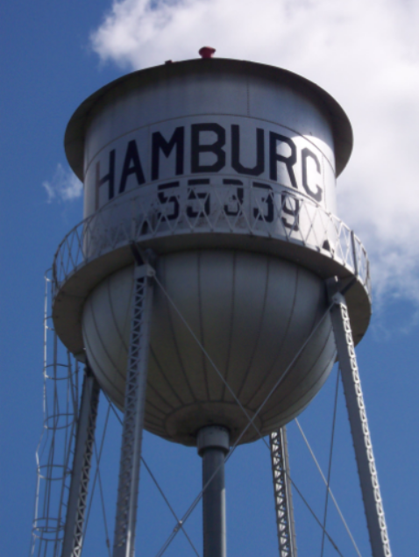

PART 2:
- Potential Contaminant Source Management Strategy
- Impacts of Expected Changes to Land and Water Resources
- Issues, Problems & Opportunities
- Wellhead Protection Plan Goals
- Management Strategies
- Evaluation Plan
- Emergency/Conservation Plan

DRAFT – February, 2008

TABLE OF CONTENTS Page Number

PUBLIC WATER SUPPLY PROFILE 3
EXECUTIVE SUMMARY 4
CHAPTER 1 - Data Elements, Assessment 6
CHAPTER 2 - Impact of Changes on Public 9
Water Supply Well(s)
CHAPTER 3 - Issues, Problems and 11
Opportunities
CHAPTER 4 - Wellhead Protection Goals 13
CHAPTER 5 - Objectives and Plans of Action 14
CHAPTER 6 - Evaluation Program 22
CHAPTER 7 - Alternative Water Supply; 23
Contingency Strategy
APPENDIX A - Referenced Data for Part 2 31

PUBLIC WATER SUPPLY PROFILE

PUBLIC WATER SUPPLY
NAME: City of Hamburg
ADDRESS: 181 Broadway Avenue
Hamburg, MN 55339
TELEPHONE NUMBER: 952-467-3232
E-MAIL: hamburgcityhall@gmail.com FAX No: 952-467-3119

WELLHEAD PROTECTION MANAGER
NAME: Jeremy Gruenhagen
ADDRESS: 181 Broadway Avenue
Hamburg, MN 55339
TELEPHONE NUMBER: 952-467-3232
E-MAIL: hamburgcityhall@gmail.com FAX No: 952-467-3119

CONSULTANT/TECHNICAL ASSISTANCE
NAME: Aaron Meyer
ADDRESS: 217 12th Avenue SE, Elbow Lake, MN 56531
TELEPHONE NUMBER: 800-367-6792 Cell: 320-808-7293
E-MAIL: aaron.meyer@mrwa.com FAX No: 218-685-5272

PART 2 EXECUTIVE SUMMARY

The City of Hamburg has two primary public supply wells and one emergency well. The City draws their water from the Franconia-Ironton-Galesville Sandstone Aquifer, which exhibits confined hydraulic conditions. The aquifer is approximately 205 feet thick and is overlain by about 300 feet of clay-rich glacial deposits and
bedrock. Generally, groundwater moves in a southeasterly direction within the Wellhead Protection Area (WHPA). The aquifer used by the water supplier is considered to exhibit a very low sensitivity to potential contamination sources due to the 300 feet of clay-rich glacial deposits and bedrock which overly the aquifer. The clay-rich glacial deposits likely prevent the vertical movement of contamination from potential sources to the aquifer. Thus the aquifer is only vulnerable to potential contaminant sources which penetrate through this geological protection. Sources of contamination which threaten the City of Hamburg’s aquifer include wells and borings.

Through the wellhead protection planning process the City was asked to predict what changes might occur within their Drinking Water Supply Management Area (DWSMA) within the next ten years. The City is expecting some limited growth of single family residential homes (approximately 25) however at the present time the City has capacity restraints at their wastewater treatment plant which will limit any growth until they are corrected. The City is not expecting any large increases in pumping rates or commercial development.

The City of Hamburg’s wellhead protection goal is to promote public health, economic development and community infrastructure by ensuring a potable drinking water supply for all residents of the community, now and into the future. The City proposes to accomplish this goal through a public education program focusing on wellhead protection awareness and proper well management and through the voluntary implementation of best management practices which address high capacity wells, domestic wells (active and unused unsealed) and Class V wells. The highest priority area for the City to protect is their Inner Wellhead Management Zone (200 foot radius around public supply wells) and their Emergency Response Area (Figure 1).

This Wellhead Protection Plan also contain information on how the City will evaluate the implementation of the identified management strategies and contingency strategies on how the City will react to a natural disaster or mechanical failure which prevents the City from providing a potable water supply to their residents.
Figure 1 — WHPA and DWSMA Map
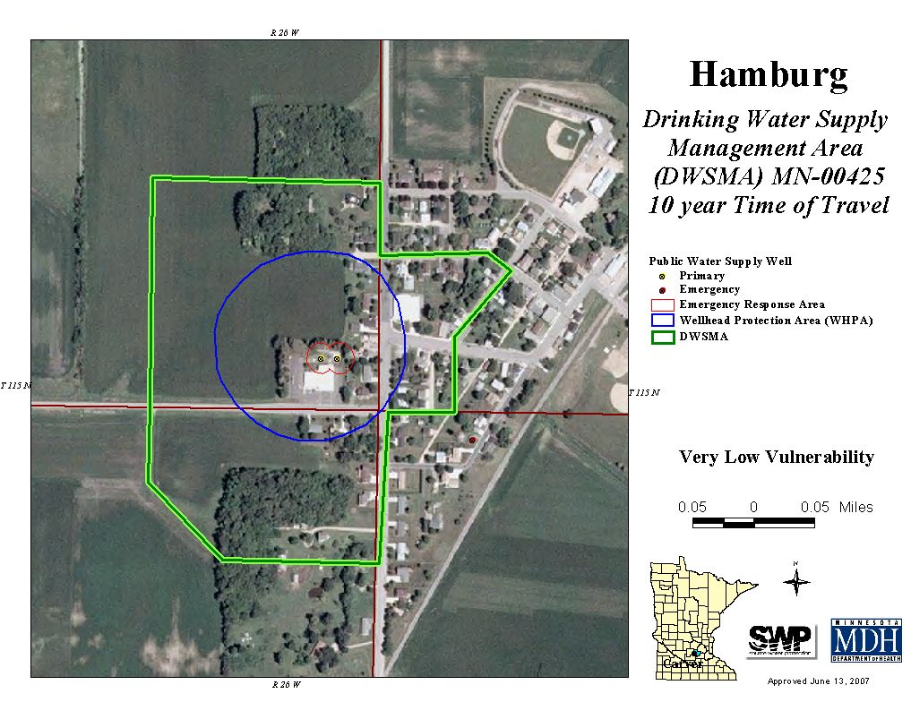
CHAPTER ONE

DATA ELEMENTS; ASSESSMENT (4720.5200)

- REQUIRED DATA ELEMENTS: The following data elements are identified in the wellhead protection rule (MN Rules 4720.5200) and must be assessed in consideration of their present and future implications upon the public water supply wells and the drinking water supply management area.

Data Element | Data Element  Required | Assessment of Data Element - Description of impacts on public water supply and wellhead protection area (future and present) | Additional Information
Physical Environment
Precipitation | Not  Required | This data element does not apply because there is not a direct hydraulic connection between surface waters and the aquifer serving this water supply system.
Geology | Required | This data element is required for and is presented in the first part of the WHP Plan. The water supply for the City of Hamburg comes from the  Franconia-Ironton-Galesville Sandstone Aquifer, which exhibits confined hydraulic conditions. The aquifer is about 205 feet thick and is overlain by about 300 feet of clay-rich glacial deposits and bedrock. Generally, groundwater moves in a southeasterly direction within the WHPA. Due to this layer of clay rich deposits the aquifer is considered to have a low vulnerability to contamination from land use activities at the land surface. Additional information and details pertaining to the geology can be found in Part 1. | WHP Part I
Soils | Not Required | This data element does not apply because there is not a direct hydraulic connection between surface waters and the aquifer serving this water supply system.
Water Resources | Required | This data element applies as it relates to future groundwater uses that may influence the ability of the aquifer to yield water to the public water supply. Increased water use may result in a reduction in aquifer yield or increase the likelihood that contaminants of human or natural origin may affect the quality of drinking water.
Land Use
Land use outside the IWMZ | Required | Due to the information contained in Part 1, this indicates that the public water supply is not vulnerable to most land-use activities, only an inventory of other wells located within the DWSMA is required. A listing of wells inventoried within the DWSMA (Figure 2) and a map showing their locations are included in the Appendix as Exhibit 1.  In general, the DWSMA is comprised of a mix of single family residential homes, commercial businesses and agricultural lands. | Appendix, Exhibit # 3  Exhibit # 7  Exhibit # 10
Land use inside the IWMZ | Required | The land uses within 200 feet of the public supply wells are primarily single family residential homes and the City of Hamburg offices and chambers. No non-conforming or non-complying potential contaminant sources were found in violation of MN Statues. | Appendix, Exhibit #2

Public Utility Services | Required | Records of well construction and maintenance apply to this portion of the plan due to the information provided about the wells and the quality and quantity of the water supplying this system.
Old Municipal Wells | Required | After reviewing past sanitary surveys, the MN Dept. of Health has documented two old municipal wells which were at one time connected to the distribution system.  The City of Hamburg believes the pump has been removed from the Car Wash well (221244) and that a cross connection exist with the City’s distribution system.  The City of Hamburg staff believe Well #1 (very first well) was located near the pumphouse by the water tower. City staff are uncertain as to the status of this well. No casing exist at the land surface but they feel it has been sealed. It might not be sealed according to current MDH standards and may pose a threat to the aquifer used by the City of Hamburg.  Well #219000 is the emergency well currently used by the City of Hamburg. | Exhibit # 8
Water Quantity
Surface Water | Not Required | This data element does not apply because there is not a direct hydraulic connection between surface waters and the aquifer serving this water supply system.
Ground Water | Required | Groundwater levels are adequate for the amounts which the City of Hamburg is currently permitted for under the groundwater appropriations program that is administered by the Minnesota Department of Natural Resources (DNR). There currently are no other high-capacity wells within the DWSMA for which well interference complaints with the system’s wells have been documented.  At this time, there appears to be sufficient groundwater quantity, based upon existing pumping capacity of the wells completed in the aquifer used by the system.
Water Quality
Surface Water | Not Required | This data element does not apply because there is not a direct hydraulic connection between surface waters and the aquifer serving this water supply system.
Ground Water | Required | This data element applies to this portion of the Plan for the City of Hamburg. Existing information consists of isotopic and chemical analyses and indicates that the aquifer used by the public water supply is recharged very slowly by surface water. As such, there is a low probability that current land use has a direct impact on the quality of drinking water. Groundwater quality information was used to determine that other wells are the primary potential sources that need to be inventoried and managed. | Appendix,  Exhibit #6
II. ASSESSMENT OF DATA ELEMENTS (continued)
A. Use of the Well -- General information describing the public water supply system is presented in the Source Water Assessment (SWA) found in Part I of this Plan. Additional information regarding treatment and distribution for the PWS system is presented in Chapter 7.

B. Wellhead Protection Area Delineation Criteria -- See Part 1 of this Plan for documentation regarding how the following delineation criteria were applied to determine the boundaries of the WHPA:
1. Time of Travel – 10 years
2. Flow Boundaries – geologic information
3. Daily Volume – provided by the system
4. Groundwater Flow Field – delineation method
5. Aquifer Transmissivity – aquifer test plan

C. Quality and Quantity of Water Supplying the Public Water Supply Well -- Water quality monitoring results indicate no evidence of contamination from 1) human origin, such as fuel and fuel break-down products, pesticides, or commercial fertilizer, or 2) naturally occurring contaminants such as arsenic and boron. At this time problems with water quality are not an issue, as the system has sufficient water quality that meets or exceeds standards in the Federal Safe Drinking Water Act.
D. Groundwater Uses in the Drinking Water Supply Management Area --
The management strategies selected and documented in Chapter 5 of this Plan will focus on activities that have the most potential to impact the aquifer this system is using for its drinking water supply. For a non-vulnerable system, other wells are the mostly likely potential impact to the aquifer.

Table 1. Types of Wells Inventoried in the Drinking Water Supply Management Area
TYPE OF WELL | NUMBER
Other Public Water Supply | 0
Commercial | 0
Domestic | 3
Observation | 0
Unused/Unsealed | 0
Sealed/Reported to MDH | 0
Class 5 Automotive | 0

CHAPTER TWO
IMPACT OF CHANGES ON PUBLIC WATER SUPPLY WELL(S) (4720.5220)

The wellhead protection team identified and described the expected changes that may occur during the next ten years. As required by MN Rule 4720.5220 changes were identified in the following general areas (1) the physical environment within the DWSMA, (2) land use, (3) surface water and (4) groundwater.

Areas of Possible Changes | Expected Change | Impact of Expected Change | Additional Information
Physical Environment | No changes in the physical composition of the aquifer are expected. | NA
Land Use | (1) Limited growth is expected to occur within the DWSMA and the City of Hamburg corporate limits due to capacity restraints at the wastewater treatment plant. If the wastewater facility is upgraded some limited growth of single family residential homes (25 homes) and light commercial will likely occur. | Due to the limited ability of the wastewater plant to treat the wastewater for the City of Hamburg no additional building will be permitted until the City can demonstrate to the MN Pollution Control Agency that they can effectively treat their current levels of wastewater. Once the wastewater plant is fixed the construction of the 25 new homes will have little impact since they are required to connect to City services and do not use large enough amounts of water to alter the boundary of the DWSMA. | Appendix, Exhibit # 4
Surface Water | No direct hydraulic connection exists between surface waters and the aquifer used by the public water supply (PWS) system. | NA
Groundwater
- Groundwater  Quality | No changes in the groundwater quality are anticipated during the next 10 years. | NA | Appendix, Exhibit # 6
- Groundwater  Quantity | Minimal increases in the pumping rates for the City of Hamburg are expected to occur within the next 10 years.  The City of Hamburg has not experienced any well interference problems or shortages in groundwater. At the present time they have sufficient amounts of groundwater to meet their demands. | NA

In addition the WHP team assessed the possible impact on the aquifer serving the public water supply wells resulting from (1) the influence of existing water and land government programs and regulations and (2) the administrative, technical and financial considerations of the public water supplier and the property owners within the drinking water supply management area.

Influence of Existing Water and Land Government Programs
Government Entity | Type of Program | Influence of Government Program on the Aquifer Serving the City of Carlos Public Water Supply Well
MN Dept. of Health | State Well Code | MDH has sole authority over the construction of new wells. New wells may act as conduits and allow contamination to enter into the aquifer used by the city.
MN Dept. of Natural Resources | State Water Use - Appropriation Permits | MN DNR has the sole authority over the amount of water high capacity wells are permitted to pump.
County Soil and Water Conservation District | Well Sealing Cost Share program | Utilizing this program will help to seal unused wells and help prevent contamination from entering into the aquifer via unused unsealed wells.

Administrative, Technical, and Financial Considerations -- The system assembled a Wellhead Protection Team early in the process of developing this Plan. Many of the activities during the planning process have been accomplished through efforts of this group, with assistance from studies provided by other units of government. For this Plan to be effective:

1. The PWS will need to raise public awareness of the issues affecting its drinking water supply through public educational programs.

2. Administrative duties will remain with the Wellhead Protection Manager, who will report to the governing authority, coordinate implementation of wellhead protection management action plans, and conduct regular meetings.

3. Funding for the implementation of this wellhead protection plan will be derived from the City of Hamburg water budget and user fees. Other sources of funding or in-kind services to help achieve the goals set forth in this Plan’s Chapter 4 include 1) the Carver County Soil and Water Conservation District who may be able to assist the city with future inventorying and sealing of unused, unsealed wells through local cost-share or other programs as available, 2) the MDH, who will assist in determining the correct measures for sealing unused wells, constructing new wells, and requiring the sealing of unused wells if this becomes necessary; and 3) the Minnesota Rural Water Association for technical assistance during the wellhead protection implementation phase.

4. The costs of implementing Wellhead Protection activities will be evaluated on an annual basis to determine whether the original cost estimates match 1) the scope of the management practices identified in this part of the Plan, 2) changes in the status of the well(s) listed in Table 1, and 3) actual costs related to proper sealing of unused/unsealed wells. The system will discuss changes in plan implementation costs with MDH to determine the availability of state or federal funding for offsetting increased costs to plan implementation.
CHAPTER THREE

ISSUES, PROBLEMS, AND OPPORTUNITIES (4720.5230)

The wellhead protection team identified water use and land use issues, problems, and opportunities related to: (1) the aquifer serving the public supply well; (2) the well water; and (3) the drinking water supply management area as required by MN Statue 4720.5230.

Areas of Possible Issues, Problems or Opportunities | Issue, Problem or Opportunity Identified by Wellhead Protection Team | Impact of Identified Issue, Problem or Opportunity upon the Public Water Supplier
The Aquifer | No issues, problems or opportunities have been identified regarding the physical makeup of the aquifer. | NA
The Well Water | The City of Hamburg currently provides a safe potable drinking water source for their residents; however the City’s drinking water is high in iron, manganese and total hardness. | The City will need to continue to treat their water for iron and manganese and flush their distribution system on a regular basis.
The Drinking Water Supply Management Area | (1) The City of Hamburg has limited land use controls within the DWSMA since the land use controls are shared between the City and Carver County.  (2) Construction of new wells both domestic and high capacity wells in or near the DWSMA.  (3) The wastewater plant needs to be upgraded to be able to provide treatment and remain in compliance during periods of high runoff or rainfall events. | (1) A joint orderly annexation agreement exists between the City and the Young America Township. The City will need to continue to have a good working relationship with Young America Township and Carver County to ensure proper land use controls are being implemented to protect the water supply for the City of Hamburg both now and into the future.  (2) A strong line of communication will need to be established between the City and MDH regarding the location of new wells and the potential impact new high capacity wells may have on the WHPA boundaries.  (3) The City of Hamburg needs to work towards upgrading their wastewater treatment facility. Significant funds and time will need to be invested in order to upgrade the plant. This will not have an impact upon the aquifer but will limit growth and the amount of water pumped by the City of Hamburg. A forced main does exist with the City of Young America.

II. IDENTIFICATION OF:

A. Problems and Opportunities Disclosed at Public Meetings and in Written Comment – At this time, no comments or concerns have been raised at public meetings or in writing regarding the development and implementation of this plan.

B. Data Elements - The state’s Wellhead Protection Rule requires that existing information be utilized in developing the initial Wellhead Protection Plan. Much of the data collected and utilized to delineate the system’s WHPA and DWSMA and to determine the vulnerability of the aquifer to contamination comes from small-scale, or regional studies. There is a limited amount of subsurface information available to define local groundwater flow conditions and the groundwater chemistry of the aquifer within the DWSMA. The direction of groundwater flow was evaluated to address concerns however the current amount of subsurface information does not permit an unquestioned determination of local groundwater flow conditions toward the system’s water supply well(s). As a result, delineation of the WHPA represents a composite of capture zones generated by varying aquifer properties, within limits determined by MDH. As additional information is collected or becomes available more concise WHPA delineations will be available.

C. Status and Adequacy of Official Controls, Plans, and Other Local, State, and Federal Programs on Water Use and Land Use - There are many tools available to the regulating agencies that may be used to achieve the wellhead protection planning goals identified by the wellhead planning team. The wellhead protection planning team recommends that no additional regulations be imposed at this time and are confident that local issues may be adequately addressed through existing processes.

Table 2. List of Government Programs available for various wellhead protection issues
Government Unit | Type of Program | Brief Program Description
MN Dept. of Health | State Well Code | MDH has sole authority over the construction of new wells and offer technical assistance for sealing unused, unsealed wells. In addition, MDH administers the Safe Drinking Water Act.
MN Dept. of Natural Resources | Appropriation Permits | Program which administers the state groundwater appropriation permits.
County SWCD | Well Sealing Cost Share program | This program will help provide cost share money to landowners to seal unused unsealed wells.
County Zoning Dept. | Zoning Ordinance | Administers land use regulations within the DWSMA.
Environment Protection Agency | Shallow Disposal Well Program | EPA has the regulatory authority over Class V Injections Well or also known as Shallow Disposal Wells.

CHAPTER FOUR
WELLHEAD PROTECTION GOALS (4720.5240)

The public water supply is located deep underground and is classified as non-vulnerable based on the geologic characteristics in the area that tend to confine the aquifer and protect it from contamination resulting from land use activities. Consequently, this WHP Plan will focus on addressing the placement and usage of other wells that may be used for domestic, public or commercial purposes.

The public water supply system has enjoyed a sufficient and safe water supply in the past, and proposes through the implementation of this WHP Plan to continue supplying safe, potable water for its customers into the future.

The goal for the City of Hamburg is to promote public health, economic development and community infrastructure by ensuring a potable drinking water supply for all residents of the community, now and into the future.
The City of Hamburg proposes to maintain a safe drinking water supply by (1) educating public officials, landowners and the general public about the importance of wellhead protection and actions they can take to protect the drinking water supply for the City of Hamburg, and (2) implementing Best Management Practices (BMPs) as needed.
CHAPTER FIVE
OBJECTIVES AND PLANS OF ACTION (4720.5250)

ESTABLISHING PRIORITIES -- The aquifer supplying the system’s drinking water supply has been identified as non-vulnerable to contamination from typical land use activities, with the exception of other wells that penetrate the confining layer to reach into the aquifer. Therefore, the Wellhead Protection Planning Team would like to concentrate management efforts on the following factors to create awareness of groundwater protection and help prevent future contamination of the aquifer:
A. Public Education
B. Well Management
1. Private Well Management
2. Inner Wellhead Management Zone
3. High Capacity Well Management
4. Class V Well Management
5. Old Municipal Well Management
C. Data Collection
D. Wellhead Protection Recognition and Planning

A. WHP EDUCATION & AWARENESS:

Objective A. Create awareness and general knowledge about the importance of WHP in the Hamburg Community.

Implementation Action Items
Action | Description | Priority | Responsible Party ® &  Cooperators © | Cost | Implementation Time Frame
 |  |  |  |  | 2009 | 2010 | 2011 | 2012 | 2013 | 2014 | 2015 | 2016 | 2017 | 2018
Action A1 | Develop and release periodic items in the local newspaper, city newsletter or through utility billings regarding WHP efforts. Topics could range from describing WHP, highlighting various management strategies / topics found in this plan. Educational materials on a variety of WHP topics are available at the Hamburg City Hall or through a MRWA or MDH Planner. | High | WHP Manager ®  Carver Co. & Carver Co. SWCD © | Staff Time | X | X | X | X | X | X | X | X | X | X
Action A2 | Collect and develop a packet of “fact sheets” addressing well management issues and make them available to residents and businesses. Contact your MRWA or MDH Planner for assistance in obtaining contact information on topics or questions on organizing packets. The majority of these fact sheets are available on the MRWA website. The packets will be made available at the Hamburg City Hall and will contain information on:  - Importance of well sealing and cost share funding available for sealing wells (MDH, MRWA, Carver Co. SWCD)  - Proper well maintenance for private wells (MDH, MRWA)  - Information on Class V Wells (MDH, MRWA) | High | WHP Manager ®  Cooperators are noted behind fact sheet listing © | $50 | X
Action A3 | Once the City of Hamburg has established a website, information regarding wellhead protection efforts within the Hamburg community will be made available on the website. | Medium | WHP Manager ® | Staff Time and $100 | X | X | X

b: Well Management Practices:

B1. Private Well Management

Objective B1: Educate and promote proper well management in the DWSMA.

Implementation Action Items
Action | Description | Priority  (H, M,L) | Responsible Party ® &  Cooperators © | Cost | Implementation Time Frame
 |  |  |  |  | 2009 | 2010 | 2011 | 2012 | 2013 | 2014 | 2015 | 2016 | 2017 | 2018
Action  B1a | The City of Hamburg will promote the sealing of abandoned wells within the DWSMA through the distribution of educational items and will share the contact information of agencies providing cost share funding options (Carver County SWCD, Carver County etc…). | High | WHP Manager ®  Carver Co. & Carver Co. SWCD © | Staff Time | X |  |  |  |  |  | X
Action  B1b | Well Management informational materials will be distributed and made available to private well owners to promote proper maintenance and management of existing wells that are located within the DWSMA. | High | WHP Manager ®  MDH & Private well owners © | Staff Time | X |  |  |  |  |  | X
Action  B1c | The wellhead protection team/manager will continually attempt to locate existing wells or new wells in the DWSMA. This will be accomplished through direct contact with landowners and through visual observation as the WHP team travels through the DWSMA. | High | WHP Manager ® | Staff Time | On- going

B2. INNER WELLHEAD MANAGEMENT ZONE ACTIVITIES:

OBJECTIVE B2: Effectively manage the IWMZ (200’ radius around public water supply well) to reduce the likelihood of contaminants from entering the well at a level to cause human health impacts.

Implementation Action Items
Action | Description | Priority | Responsible Party ® &  Cooperators © | Cost | Implementation Time Frame
 |  |  |  |  | 2009 | 2010 | 2011 | 2012 | 2013 | 2014 | 2015 | 2016 | 2017 | 2018
Action  B2a | Assist MDH staff in completing the Inner Wellhead Management Zone Inventory for the public water supply wells every three years. | High | MDH ®  WHP Manager© | Staff Time |  |  | X |  |  | X |  |  | X
Action  B2b | The WHP Team will continue to monitor setbacks for all new potential sources of contamination located within the IWMZ. | High | WHP Manager ® | Staff Time | On-going
Action  B2c | The WHP Committee will develop wellhead protection measures to address any new potential contaminant sources identified in future IWMZ inventories/surveys. | High | WHP Manager ® | Staff Time | As Needed
Action  B2d | Implement the WHP Measures identified in the IWMZ Inventory (see Exhibit #2 or future updated Sanitary Survey Reports). | High | WHP Manager ® | Staff Time | As Needed

B3. High Capacity Well Management

Objective B3: Identify any new high capacity wells that are proposed in the DWSMA so their impact on the public water supply wells can be determined.

Implementation Action Items
Action | Description | Priority | Responsible Party ® &  Cooperators © | Cost | Implementation Time Frame
 |  |  |  |  | 2009 | 2010 | 2011 | 2012 | 2013 | 2014 | 2015 | 2016 | 2017 | 2018
Action  B3a | Collaborate with the MDH Source Water Protection Unit in the identification of new high-capacity wells that are proposed for construction within the DWSMA or one mile of the DWSMA boundary. The WHP Manager will alert the MDH Source Water Protection Unit upon learning about the construction or use of a high capacity well in the DWSMA. Potential impacts will be evaluated by MDH. | High | WHP Manager ®  Carver Co. & Carver Co. SWCD © | Staff Time | On-going
Action  B3b | If a high capacity well is identified the wellhead protection manager, working in cooperation with MDH, will contact the well owner and provide them a map of the DWSMA and discuss the possible impact the high capacity well might have on the Hamburg drinking water supply. | High | WHP Manager ®  MDH & Private well owners © | Staff Time | As Needed

b4. CLASS V WELLS (Shallow Disposal System):

OBJECTIVE B4: Create awareness among commercial enterprises, local automotive shops, or garages about what a Class V well is and Federal EPA registration, permitting and reporting requirements for Class V Wells.

Implementation Action Items
Action | Description | Priority | Responsible Party ® &  Cooperators © | Cost | Implementation Time Frame
 |  |  |  |  | 2009 | 2010 | 2011 | 2012 | 2013 | 2014 | 2015 | 2016 | 2017 | 2018
Action B4a | In the event a Class V well is identified the wellhead manager will work cooperatively with MDH to determine the status of the shallow disposal system and what reporting steps may be needed to register the Class V well with EPA. EPA reporting forms are available at: www.epa.gov/safewater/uic/7520s.html ). In addition, information will be provided to the landowner on technical services available thru MNTAP to assess management and / or disposal alternatives. (No Class V Automotive Disposal Wells were identified at this time) | Low | WHP Manager ®  MDH © | Staff Time | As Needed

b5. Old municipal well manangement:

OBJECTIVE B5: Locate, inventory and properly management the old Hamburg municipal wells which may now be a potential contaminant sources and threaten the water quality within the aquifer used by the City of Hamburg.

Implementation Action Items
Action | Description | Priority | Responsible Party ® &  Cooperators © | Cost | Implementation Time Frame
 |  |  |  |  | 2009 | 2010 | 2011 | 2012 | 2013 | 2014 | 2015 | 2016 | 2017 | 2018
Action B5a | Working in cooperation with the MDH Sourcewater Protection Unit and Well Management Unit locate, inventory and properly manage all old municipal wells. Once the City and the MDH Well Management Unit have located the old municipal wells the City will follow the recommendations of the MDH on how to properly address the located municipal wells. | High | WHP Manager ®  MDH © | Staff Time | X | X | X | X
Action B5b | Working in cooperation with MDH, the City of Hamburg and MDH will contact the owner of the Car Wash well and assist the owner in sealing the well or bringing the well into compliance with the MDH Well Management Unit. The city will explore the option of providing some financial assistance to help seal the well. | High | WHP Manager ®  MDH and Car Wash Owner © | Staff Time | X | X

C. DATA COLLECTION:

OBJECTIVE C1: Gather additional information regarding surface water levels within the DWSMA in order to better understand the interaction of surface waters and recharge rates to the aquifer from which Hamburg draws their water.

Implementation Action Items
Action | Description | Priority | Responsible Party ® &  Cooperators © | Cost | Implementation Time Frame
 |  |  |  |  | 2009 | 2010 | 2011 | 2012 | 2013 | 2014 | 2015 | 2016 | 2017 | 2018
Action  C1a | Working in cooperation with MDH, determine the locations of new wells drilling within 3 miles of the Hamburg DWSMA. Identifying the location of new wells will help the MDH Hydro Geologist eliminate some of the uncertainties in delineating the wellhead protection area. | High | MDH ®  WHP Manager© | Staff Time |  |  |  |  |  | X

D. WELLHEAD PROTECTION RECOGNITION AND PLANNING:

OBJECTIVE D1: Identify Wellhead Protection (WHP) and the DWSMA in future revisions to local land use and resource planning documents. Consideration should be given to how future land uses or changes may impact local groundwater resources and the City of Hamburg’s public water supply.

Implementation Action Items
Action | Description | Priority | Responsible Party ® &  Cooperators © | Cost | Implementation Time Frame
 |  |  |  |  | 2009 | 2010 | 2011 | 2012 | 2013 | 2014 | 2015 | 2016 | 2017 | 2018
Action  D1a | Through the joint orderly annexation agreement between the City and Young America Township mail a map and letter requesting that Young America Township and Carver County recognize the City of Hamburg’s DWSMA when making land use decisions. | High | WHP Manager®  Carver County and Young America Township© | Staff Time | X
Action D1b | The City of Hamburg will incorporate wellhead protection and the management of their DWSMA into their comprehensive plan and future revisions as needed. | High | WHP Manager ® | Staff Time | X | X | As needed

CHAPTER SIX
EVALUATION PROGRAM (4720.5270)

The success of the wellhead protection management program must be evaluated in order to determine whether the plan is actually accomplishing what the public water supply system set out to do. The following activities will be implemented to:
- Track the implementation of the objectives identified in Chapter 5 of this Plan;
- Determine the effectiveness of specific management strategies regarding the protection of the public water supply;
- Identify possible changes to these strategies which may improve their effectiveness; and
- Determine the adequacy of financial resources and staff availability to carry out the management strategies planned for the coming year.

- The public water supply system will continue to cooperate with the Minnesota Department of Health in the annual monitoring of the water supply to determine whether the management strategies are having a positive effect and to identify water quality problems that may arise which must be addressed.
- Members of the wellhead protection team, the governing authority, and the WHP plan manager will travel through the drinking water supply management area on a regular basis to identify any changes in land use or potential contaminant source management practices which may adversely impact the public water supply.
- The wellhead protection team will meet on an as-needed basis, with a minimum of one annual meeting, to review the results of each strategy implemented during the previous plan year and identify and discuss whether modifications are needed for those strategies and additional strategies for the coming plan year.
- The wellhead protection plan manager will make an annual written report or utilize tools developed by MRWA to update/inform the governing authority regarding progress in implementing the wellhead protection management objectives of this Plan. The annual reports will be compiled and used to review the overall progress in implementing source water management strategies when the public water supply’s wellhead protection plan is updated in 10 years. A copy of the report will be sent to the MDH Source Water Protection Unit in St. Paul and another copy will be placed in the system’s Wellhead Protection file.

CHAPTER SEVEN
ALTERNATIVE WATER SUPPLY; CONTINGENCY STRATEGY (4720.5280)

INDEX
A. PURPOSE

B. PUBLIC WATER SUPPLY CHARACTERISTICS

- Current Supply Source
- Treatment
- Storage and Distribution
- Maps and Plans

C. PRIORITY OF WATER USERS DURING WATER SUPPLY EMERGENCY

D. ALTERNATIVE WATER SUPPLY

- Surface Water Sources and Treatment
- Bottled Water
- System Interconnects
- Other Alternative Water Resources

- INVENTORY OF AVAILABLE EMERGENCY EQUIPMENT AND MATERIALS

- EMERGENCY IDENTIFICATION PROCEDURES

- NOTIFICATION PROCEDURES

- Agency Contact List
- Critical Response Personnel
- Public Information Plan

- MITIGATION AND CONSERVATION PLAN

1. Mitigation
2. Conservation

A. PURPOSE

The purpose of this Contingency Plan is to establish, provide and keep updated, certain emergency response procedures and information for the City of Hamburg, MN which may become vital in the event of a partial or total loss of public water supply services.

B. PUBLIC WATER SUPPLY CHARACTERISTICS

1. Current Supply Source

City of Hamburg | Well  Number 1 | Well  Number 2A | Well  Number 3
Unique Well # | 219000  (Emergency Well) | 691883 | 691884
Supply Source | Franconia-Ironton-Galesville | Franconia-Ironton-Galesville | Franconia-Ironton-Galesville
Well Depth (ft.) | 745 | 620 | 620
Well Diameter (in.) | 6 | 12 | 12
Well Capacity (gpm) | 70 | 150 | 150
Well Production (gpm) | 70 | 145 | 145

2. Treatment
The City of Hamburg adds chlorine, fluoride and has an iron and manganese removal system in place at their well house. In addition, the City utilizes a detention and pressure filtration system. Well #1 is used as an emergency well while Wells #2A and #3 are the primary wells for the City of Hamburg.
3. Storage and Distribution
The City has one 55,000 gallon above ground storage tank which supplies all of the water for the town. The majority of the water distribution system is looped, with the exception of 10 dead ends in the system. The water system contains all other necessary valving and piping and is considered to be in good shape according to City staff. The majority of the distribution system is comprised of cast iron pipes.
4. Maps/Plans
Maps of the water distribution system and valving are on file at the Hamburg City Hall, City Shop and City Engineer’s Office.

C. PRIORITY OF WATER USERS DURING WATER SUPPLY EMERGENCY

Table C—Water Use Priority Grouping

Priority Group and Rank | Maximum daily use (gpd) | Minimum daily use (gpd)
Residential #1 | 93,000 | 25,000
Commercial/Industrial #2 | 1000 | 500
Unaccounted | NA - <10% | NA - <10%

Triggers for implementing water supply reduction/allocation Procedures:

In the event of a major system disruption, failure or an emergency, conservation procedures would be enacted by the Water Operator, City Clerk/Treasurer, Mayor and City Council.

D. ALTERNATIVE WATER SUPPLY OPTIONS

1. Surface water sources and treatment needs. NA

2. Bottled water supplies, delivery and distribution: The City of Hamburg will obtain bottled water from the following stores:
  - Jerry’s HQ Arlington, MN 507-964-2246
  - Coborn’s Glencoe, MN 320-864-6132
  - Wal-Mart Hutchinson, MN 320-587-1020
  - Econo Foods Norwood, MN 952-467-1999

3. System interconnects with other water supplies. The City of Hamburg does not have any inter connects with their distribution system.

4. New well. No other new wells are planned at this time.

5. Emergency or backup wells. The City of Hamburg utilizes Well #1 as their emergency well.

6. Emergency treatment of water system. The City of Hamburg owns a generator which can supply power due emergency events.

7. Source Management (blending). The City of Hamburg has the ability to blend their water supply.

8. Other. No other water supply alternatives have been identified by the City of Hamburg at this time.

E. INVENTORY OF AVAILABLE EMERGENCY EQUIPMENT AND MATERIALS
Table E-1 contains a list of services, equipment and supplies that are available to the City (system) to respond to a disruption in the water system. It is believed that the items contained in Table E-1 would be adequate to respond to most (if not all) water system emergencies.

Table E-1–Available Emergency Equipment and Materials

Description | Owner | Telephone | Location | Acquisition Time
Well Repair | Hydro Engineering | 952-467-3100 | Norwood – Young America, MN | 1 hr
Pump Repair | Hydro Engineering | 952-467-3100 | Norwood – Young America, MN | 1 hr
Electrician | Robb’s Electric | 952-448-4030 | Carver, MN | 1 hr
Plumber | Henning Excavating  Juul Contracting | 612-210-5285  320-587-2989 | New Germany, MN  Hutchinson, MN | 1 hr  1 hr
Backhoe/ Excavator | Henning Excavating  Juul Contracting | 612-210-5285  320-587-2989 | New Germany, MN  Hutchinson, MN | 1 hr  1 hr
Chemical Feed | Hawkins Water Treatment | 612-331-6910 | Minneapolis, MN | 2 hrs
Meter Repair | Hydrometering Technology | 800-325-0514 | Burnsville, MN | 1.5 hrs
Generator | Ziegler Power Systems | 888-320-4292  952-445-4292 | Shakopee, MN | 1 hr
Valves, Pipe & Fittings | Henning Excavating  Juul Contracting | 612-210-5285  320-587-2989 | New Germany, MN  Hutchinson, MN | 1 hr  1 hr
Air Compressor | Tonka Equipment Company | 763-559-1979 | Plymouth, MN | 2 hr

- NOTIFICATION PROCEDURES

1. Agency Notification

Table I-1 contains the names and telephone numbers for contacts at various local and state agencies that may be notified in the event of a public water supply system emergency. Based on the nature of the emergency and the information available, various representatives from this listing will be selected by the response coordinator to be part of the emergency oversight committee which will then meet throughout the duration of the emergency to aid in decision-making and positive outcomes.

Table I-1– Agency Emergency Contact Listing
CITY OF HAMBURG
PHONE NUMBERS
NAME | Position | HOME | WORK | Cell Phone | Response Involvement or Role
Jeremy Gruenhagen | City Clerk-Treas. | 952-467-4447 | 952-467-3232 | 952-393-4447 | Alternate Response Coordinator
Dennis Byerly | City Maintenance | 952-467-2677 | 952-467-3046 | 952-465-5549 | Incident Assessment Team
Susan Block | Deputy Clerk | 952-467-3263 | 952-467-3232 | 612-597-3919
Mike Buckentin | Mayor | 952-467-3427 |  | 612-581-1101 | Incident Assessment Team
Larry Mueller | Asst. Mayor | 952-467-2355 | 952-988-8420 | 612-419-0961 | Incident Assessment Team
Diane Mackenthun | Council Member | 952-467-3534 |  |  | Incident Assessment Team
Brian Cummiskey | Council Member | 952-467-3553 |  |  | Incident Assessment Team
Steve Trebesch | Council Member | 952-467-2767 |  | 952-412-8310 | Incident Assessment Team
Brad Droege | Fire Chief - Brad | 952-467-3672 | 952-467-2720 | 612-581-9289 | Response Coordinator
Carver County Sheriff | Policing Department |  | 952-361-1231 |  | Incident Assessment Team
Community Service Officer | Carver County Sheriff |  | 952-201-9593 | 952-201-6477
Doug Parrott | City Engineer (SEH) |  | 800-838-8666 |  | Incident Assessment Team
John Thom | Water Dept (SEH) |  | 651-765-2965 | 612-618-9804 | Incident Assessment Team
Craig Anderson | I/I Program (SEH) |  | 612-758-6727
Kreg Schmidt | Bolton & Menk |  | 952-448-8838 | 612-619-5756
MN Pollution Control Agency | PCA |  | 800-422-0798
Duty Officer | PCA |  | 651-649-5451
Xcel Energy | Electricity & NG |  | 800-895-1999
Michelle Swanson | Xcel Energy |  | 952-829-4504
Sprint | Telephone |  | 800-786-6272
Sharon Parpart | Sprint |  | 952-448-8292
MDH Engineer | Isaac Bradlich |  | 651-643-2102 |  | Incident Assessment Team
MDH Sourcewater Protection | Terry Bovee |  | 507-389-6597
MN Rural Water Assoc. | Jeff Dale, Aaron Meyer |  | 800-367-6792

2. Critical Response Personnel

Table I-2 Incident Assessment Team
Contact | Home Phone | Work Phone
Michael Buckentin - Mayor | 952-467-3427 | NA
Larry Mueller - Council Members | 952-988-8420 | 952-988-8420
Diane Mackenthun - Council Members | 952-467-3534 | NA
Brian Cymmiskey - Council Members | 952-467-3553 | NA
Steve Trebesch - Council Members | 952-467-2767 | NA
Dennis Byerly- System Operator | 952-467-2677 | 952-465-5549
Jerermy Gruenhagen – City Clerk | 952-467-3232 | 952-393-4447
Brad Droege - Fire Chief | 911 | 952-467-2720
Carver County Police Department | 911 | 952-361-1231
Chris Weldon – Carver County Emergency Director | 911 | 952-361-1527
Duty Officer  MN Pollution Control Agency  ( Hazardous Materials Response) | 911 | 800-422-0798  800-657-3864
Isaac Bradlich - MDH District Engineer | NA | 651-643-2102
Doug Parrott – SEH  Hamburg City Engineer | NA | 800-838-8666

3. Public Information Plan:

- Public relations center and primary spokesperson:

Name: Brad Droege
Title: Fire Chief
Address: Hamburg Fire Department, 181 Broadway Ave. Hamburg, MN 55339
Home Phone: 952-467-3672
Work Phone: 952-467-2720

Public Information Center Location during Emergency:
Hamburg City Hall

Times Available: 8 AM – 4:30 PM and as needed

Alternate Information Center Location Site: Hamburg Community Hall 351 Henrietta Avenue, Hamburg

- Information checklist to be conveyed to the public and media:

- Name of Water System
- Contaminant of concern & date
- Source of contamination
- Public Health Hazard
- Steps the public can take
- Steps the water system is taking
- Other Information

- Media Contacts:

Media | Name | Telephone | Address
Newspaper | Norwood Young America Times | 952-467-2271 | 410 Faxon Road  Norwood Young America, MN 55368
Television | WCCO Ch. 4  KARE 11 | 800-444-WCCO  763-546-1111 | WCCO-TV  90 S. 11th Street  Minneapolis, MN 55403  KARE 11  8811 Olson Memorial Hwy, Minneapolis, MN 55427
Radio | WCCO 830 AM | 800-327-8255 | WCCO Radio  625 Second Avenue South  Minneapolis, MN 55402
In addition the City will utilize mass mailings and the Community Service Officers as needed in the case of an emergency.

- MITIGATION AND CONSERVATION PLAN

- MITIGATION

- Infrastructure maintenance/upgrades/maps:
The water system is flushed two times a year and as needed based on complaints and water quality. Infrastructure maintenance and upgrades are performed as needed and the system is considered to be in good shape according to City staff.

- Regular inspection of tower, well, pump house:
All of these items are inspected daily. The well house and chemical rooms have keyed entries and are locked. The water tower is inspected annually.

- Staff emergency training:
City staff receive training through the Minnesota Rural Water Association.

- System security analysis:
All facilities are locked and have keyed entries.

- Site new backup well:
No new well is planned at this time.

- System valving to isolate problems:
The water system is valved to isolate problems. The distribution system is flushed annually, however, due to the fact the system has six deadends these areas are flushed 3-4 times a year.

- Sanitation procedures for construction/repairs:
Shock chlorination is done when needed. All disinfection procedures are performed per State specifications.

- CONSERVATION

- Water Meters: The City of Hamburg has water meters installed on 100% of homes and businesses connected to the system.

- Public Education:
The City of Hamburg provides their consumer confidence report to their water users through the Norwood Young America Times newspaper and the city web site.

- Rate structure:

Water rates: Minimum rate of $14.50/month and $6.90 per 1000 gallons there after.

Waste Water rates: Minimum rate of $10.50/month and $4.40 per 1000 gallons there after.

Additional information regarding emergency management and water conservation can be found in the City of Hamburg’s Water Supply Plan which has been approved by the Department of Natural Resources. The Hamburg Water Supply plan is located at the Hamburg City Hall.
APPENDIX

Exhibits

Exhibit #1 Potential Contaminant Source Inventory
Exhibit #2 Inner Wellhead Management Zone Inventory
Exhibit #3 Hamburg Zoning Map
Exhibit #4 City of Hamburg Ordinance
Exhibit #5 Local Units of Government
Exhibit #6 2006 Consumer Confidence Report
Exhibit #7 Land Cover Map
Exhibit #8 City of Hamburg Old Municipal Wells
Exhibit #9 Scoping II Notice
Exhibit #10 Hamburg Development Plan

Exhibit #1 – Potential Contaminate Source Inventory

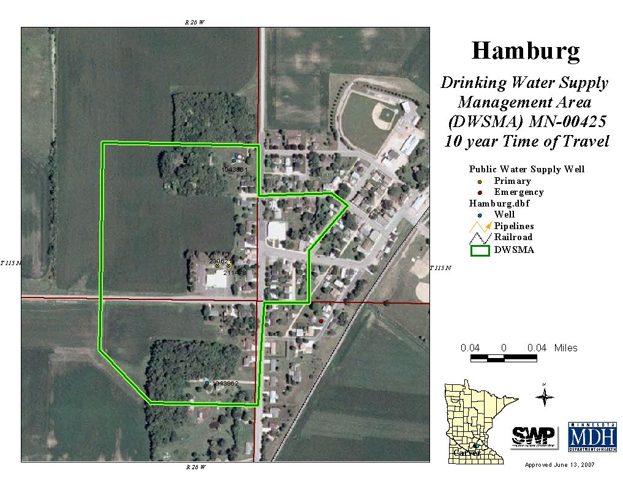

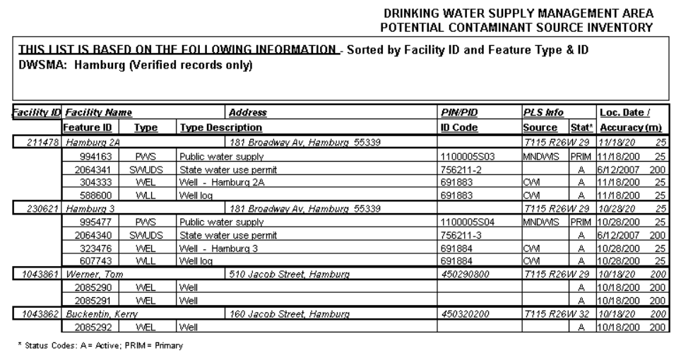
Exhibit 2 – Inner Wellhead Management Zone Inventory

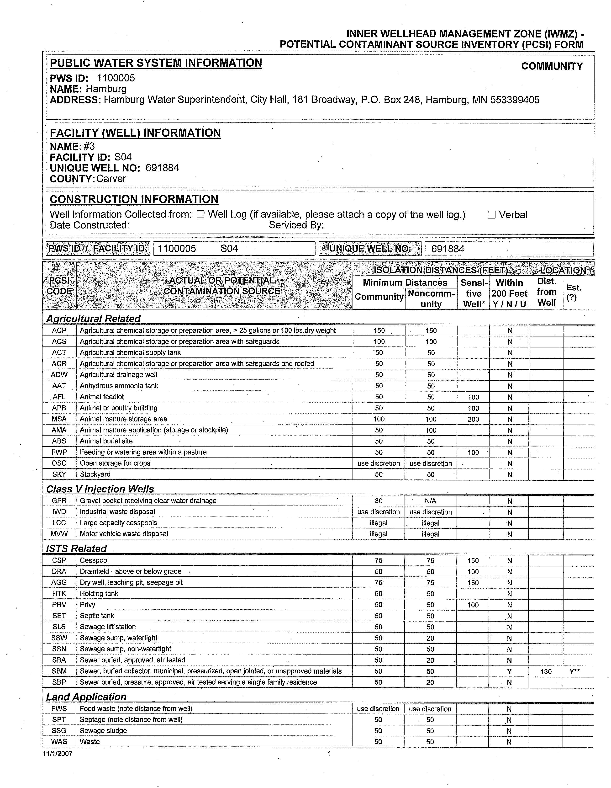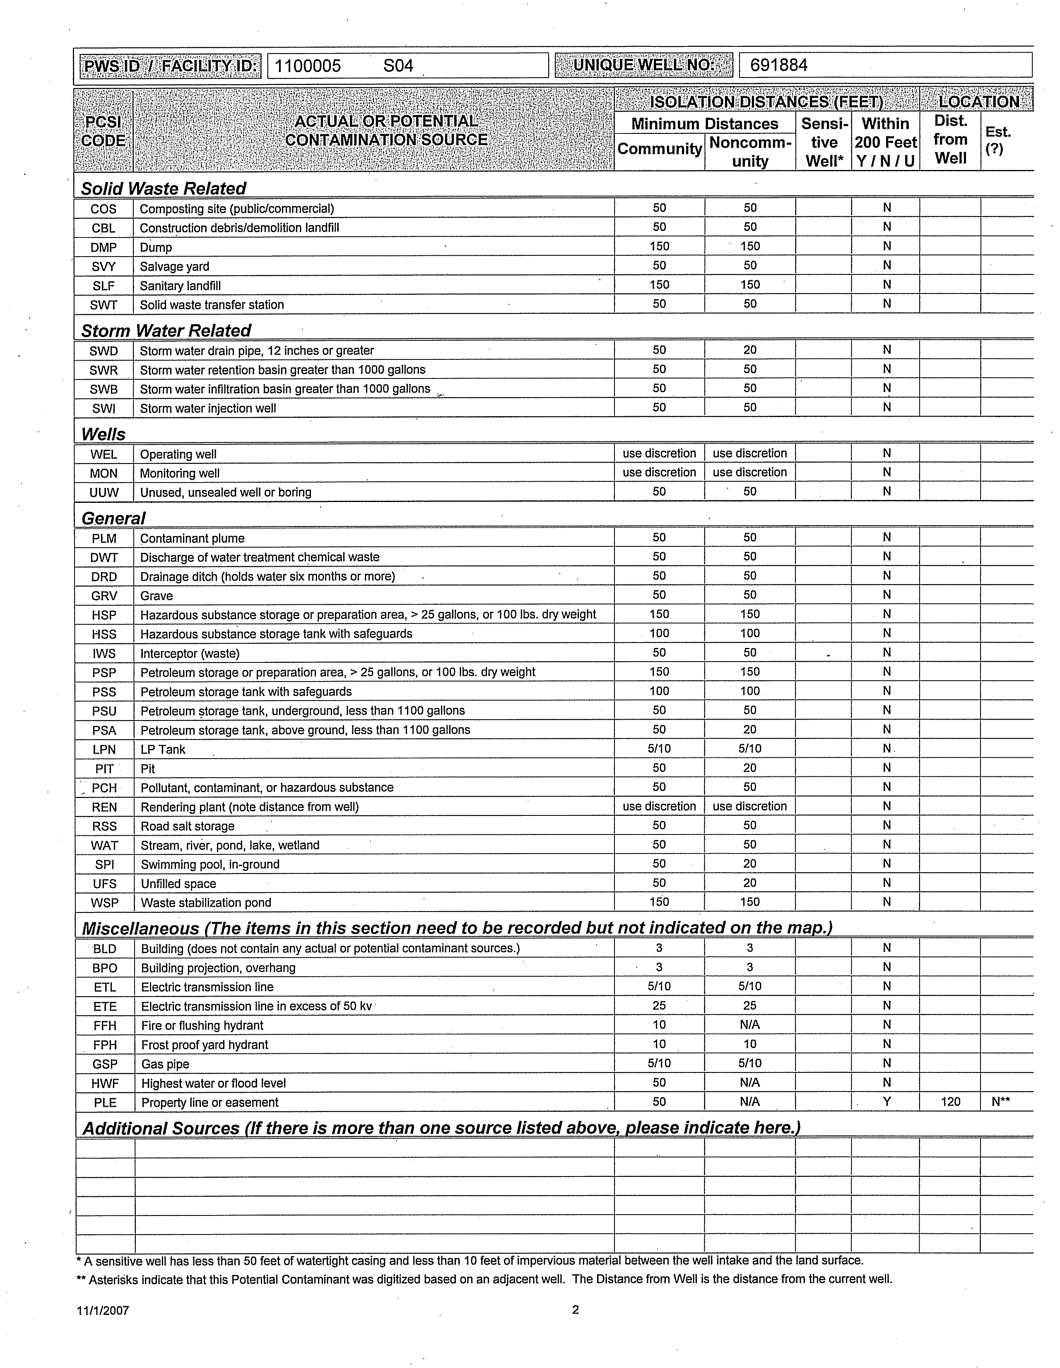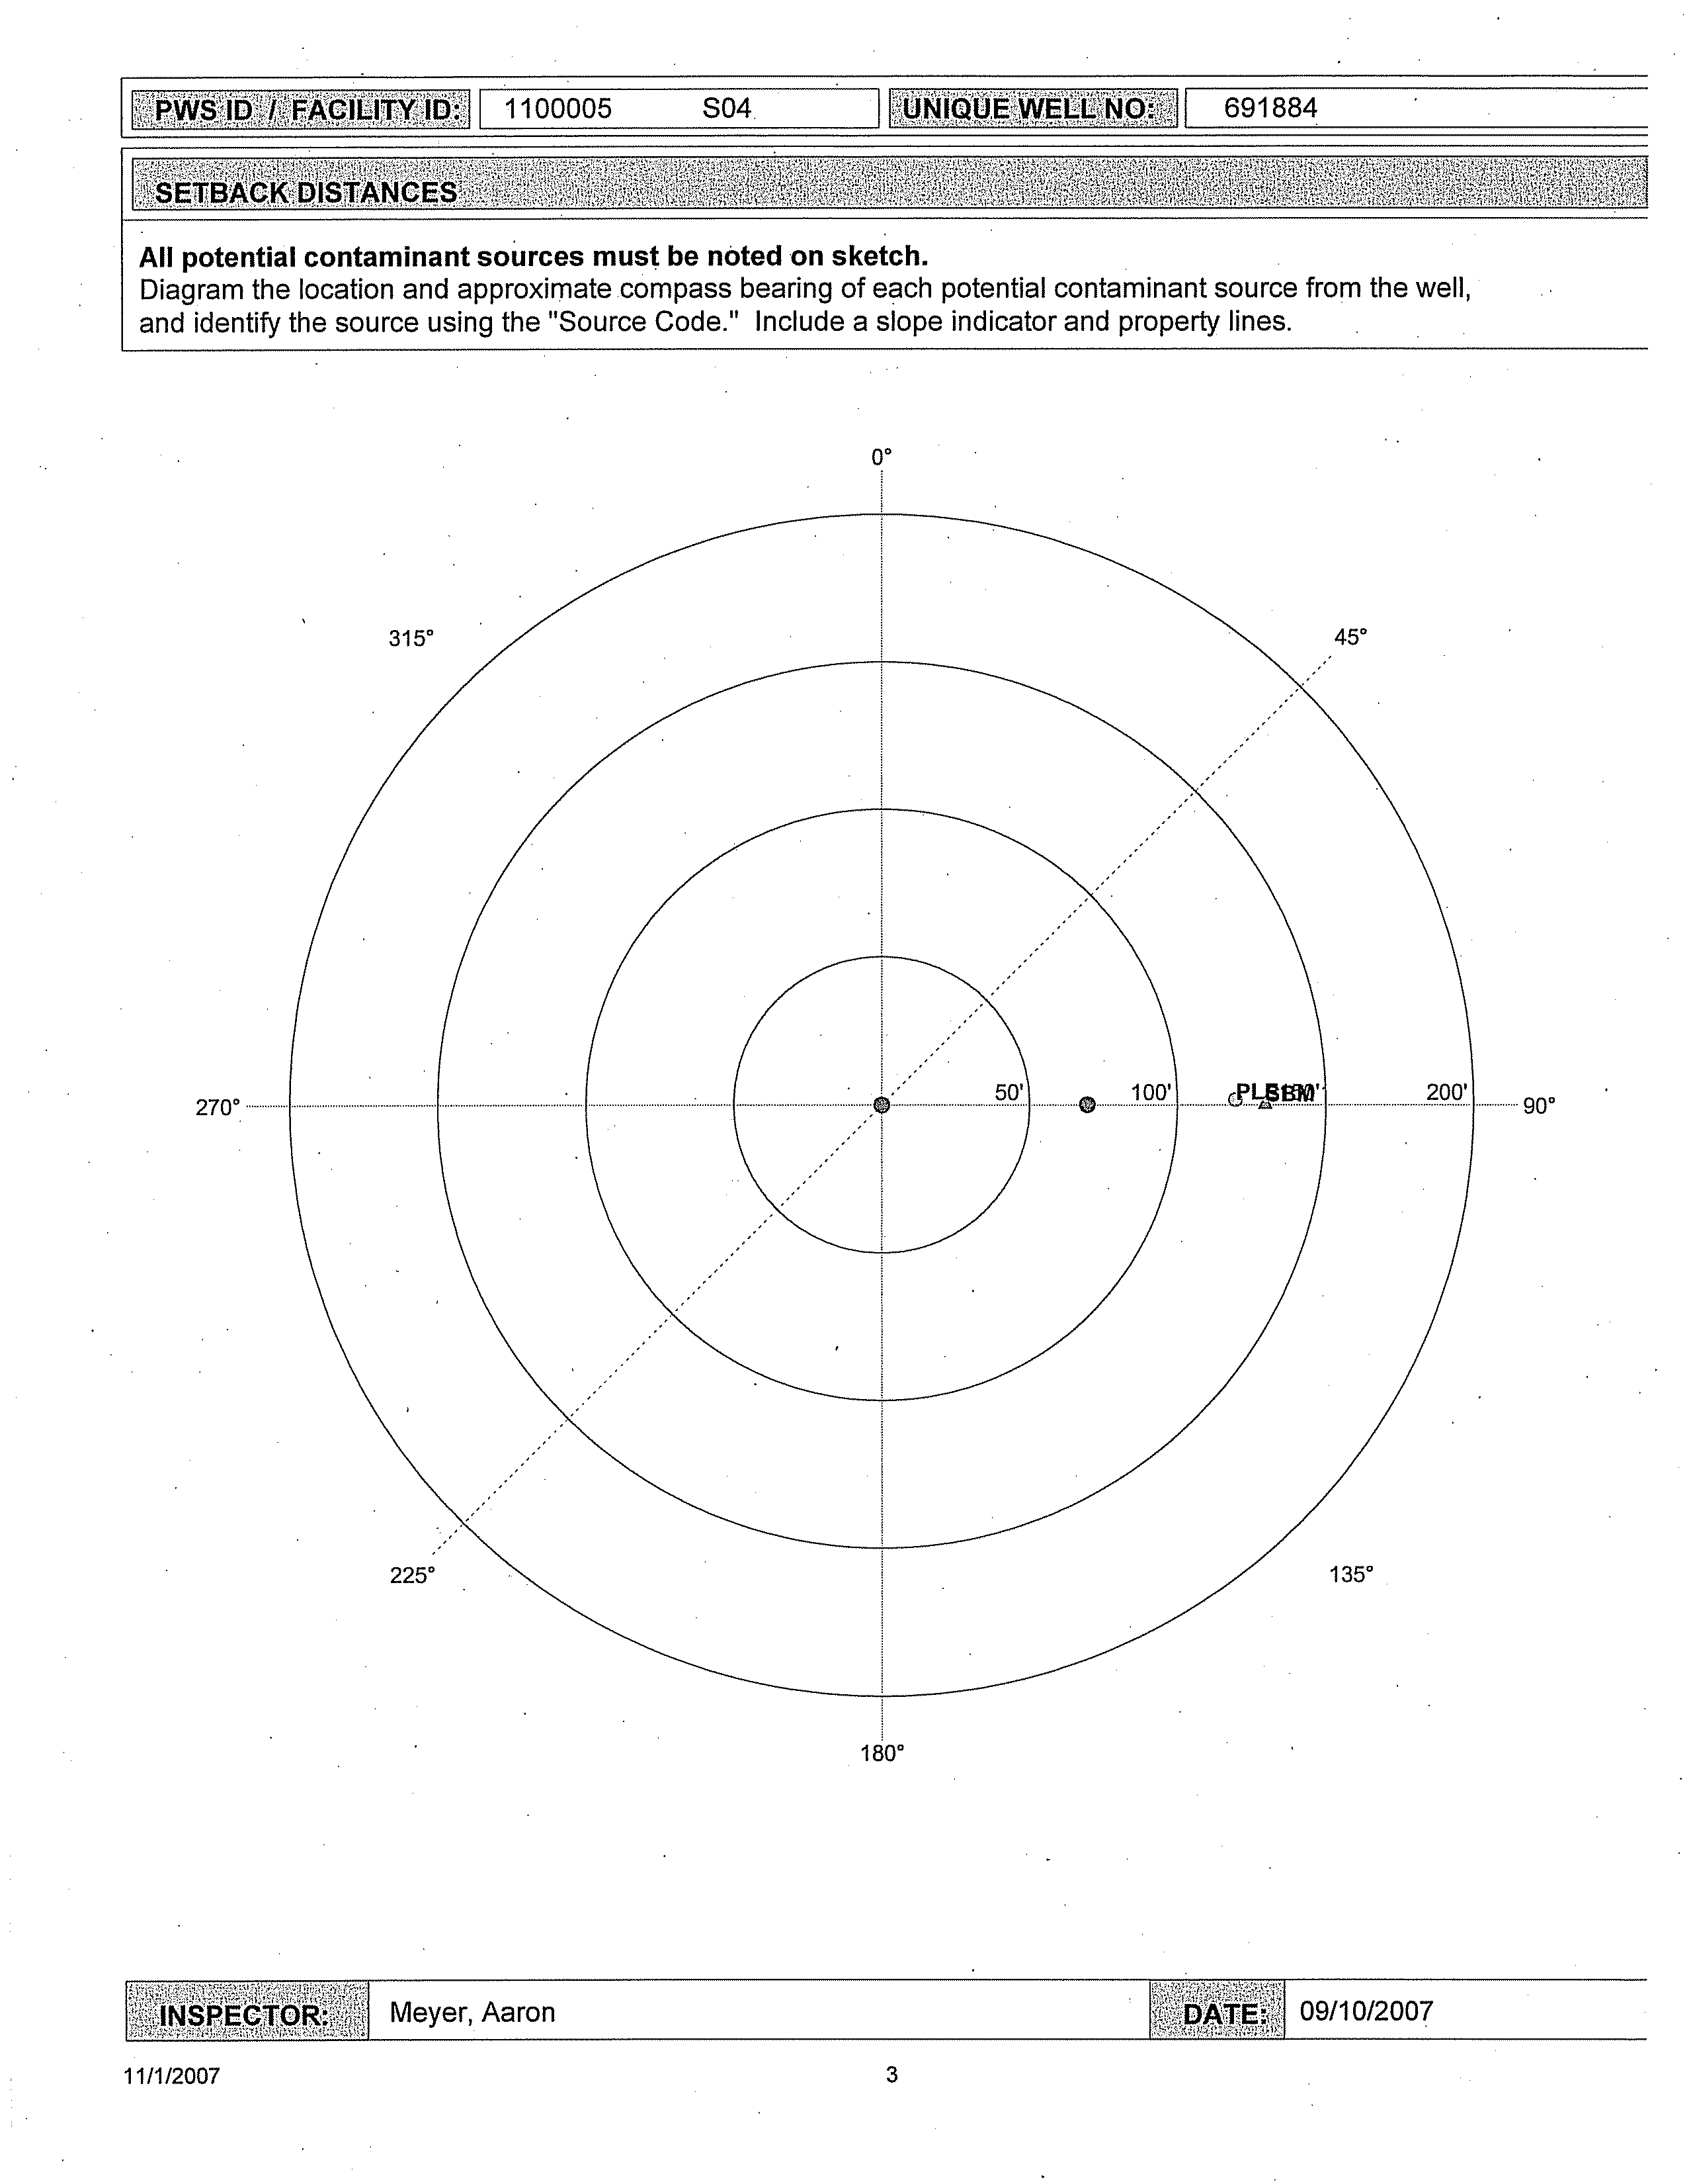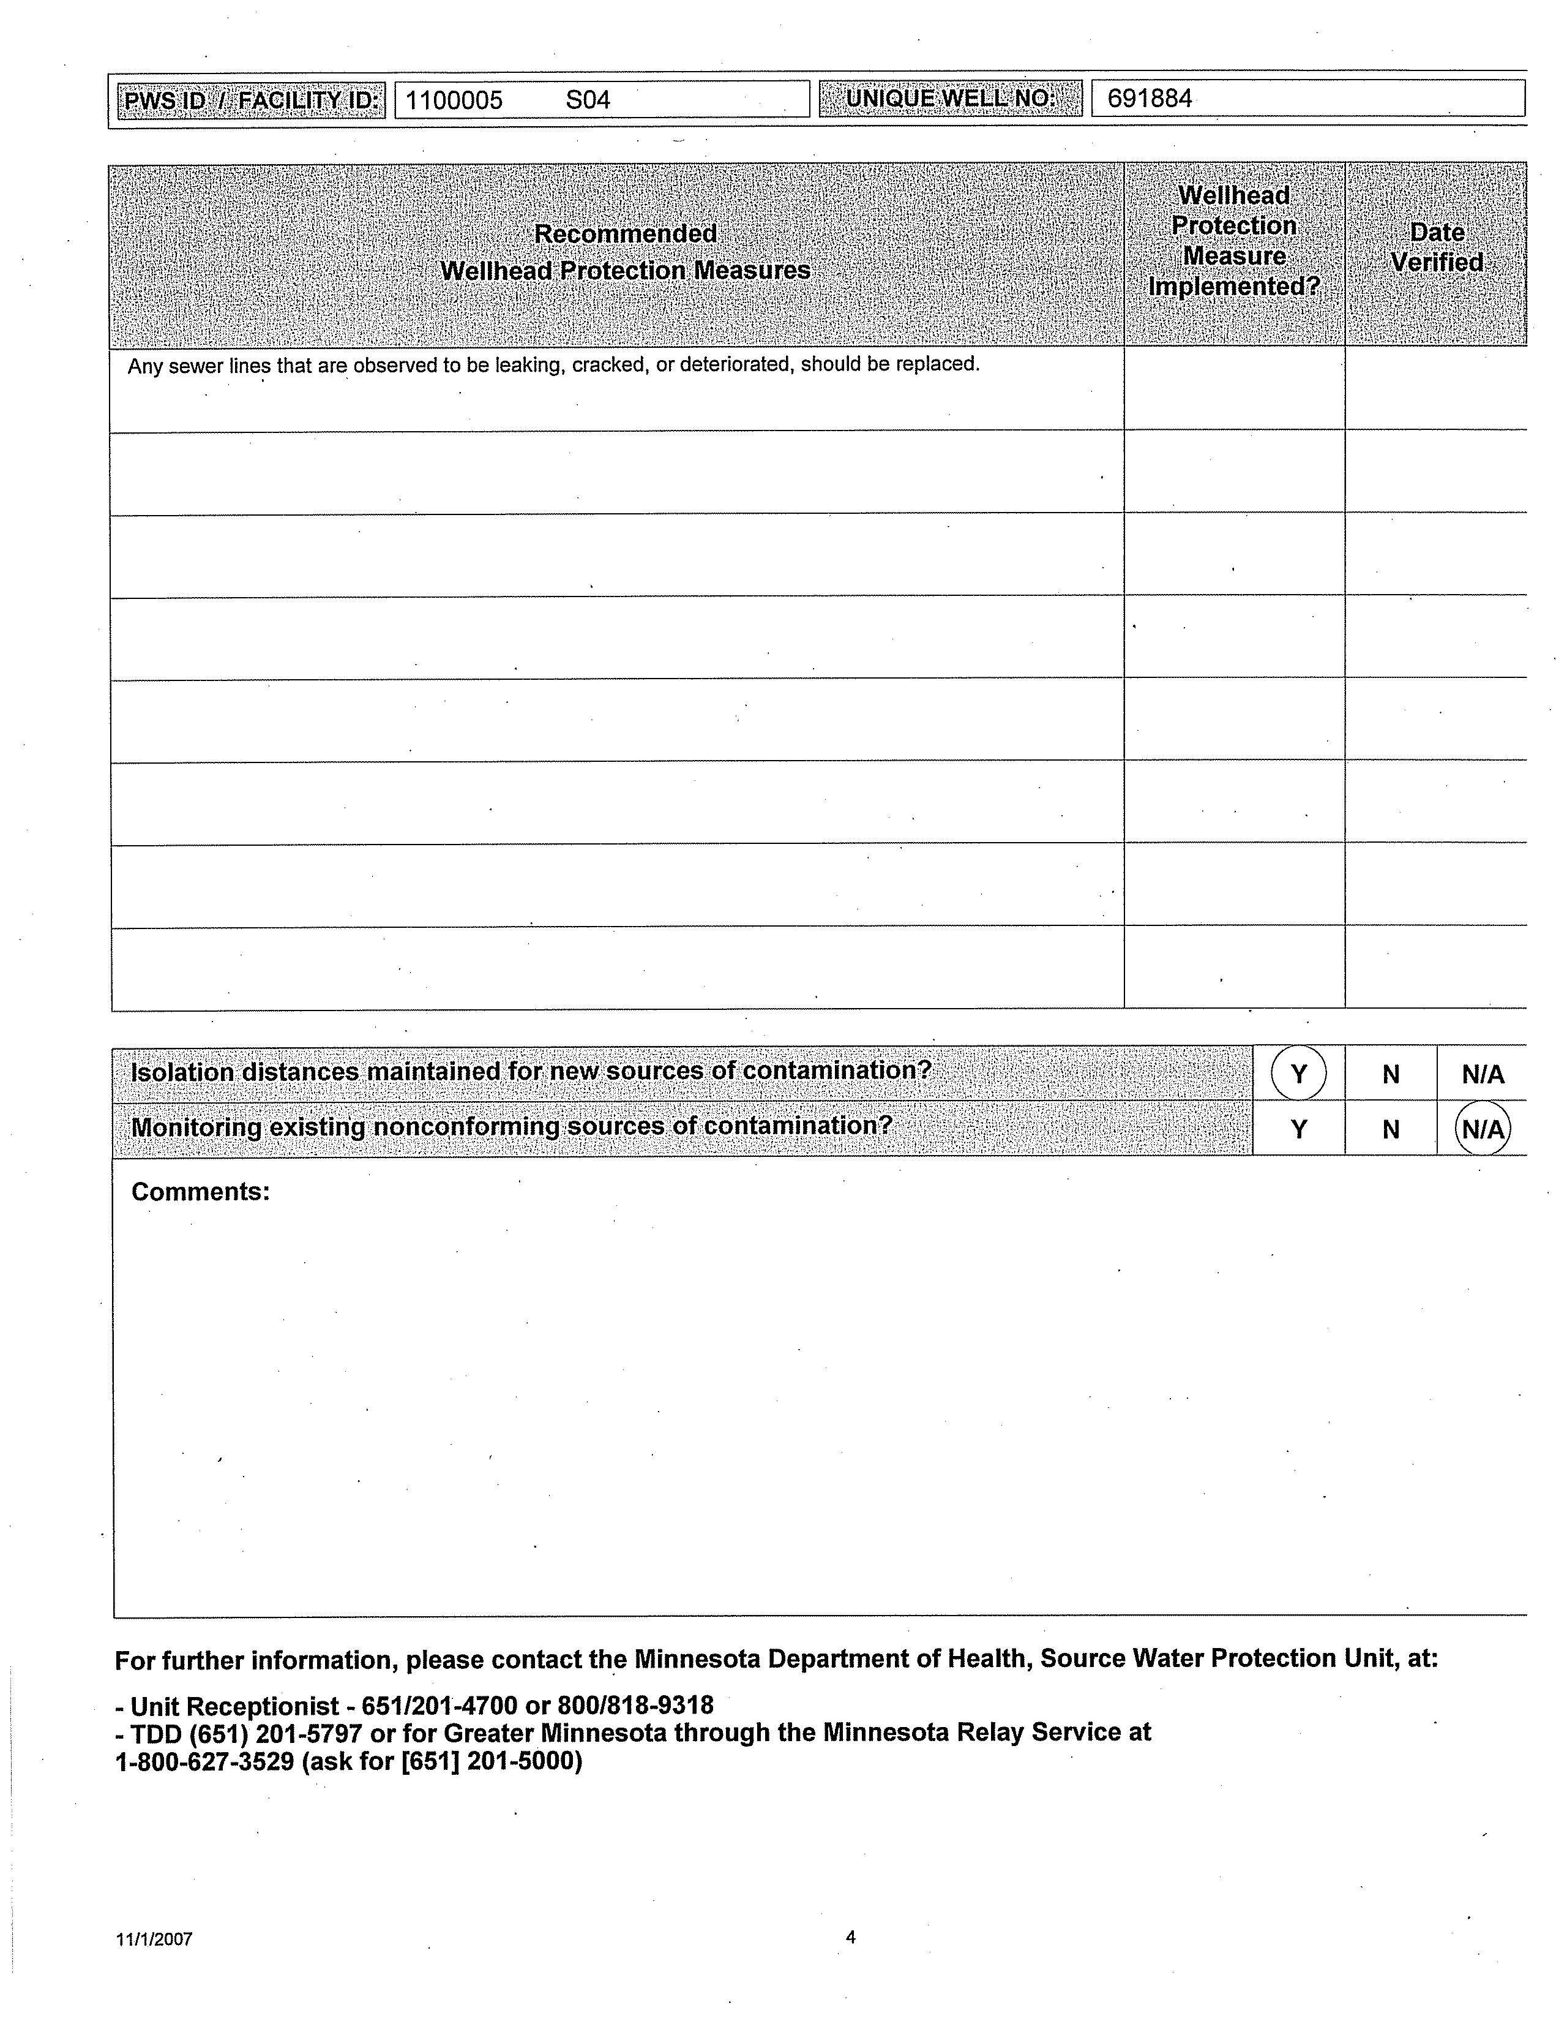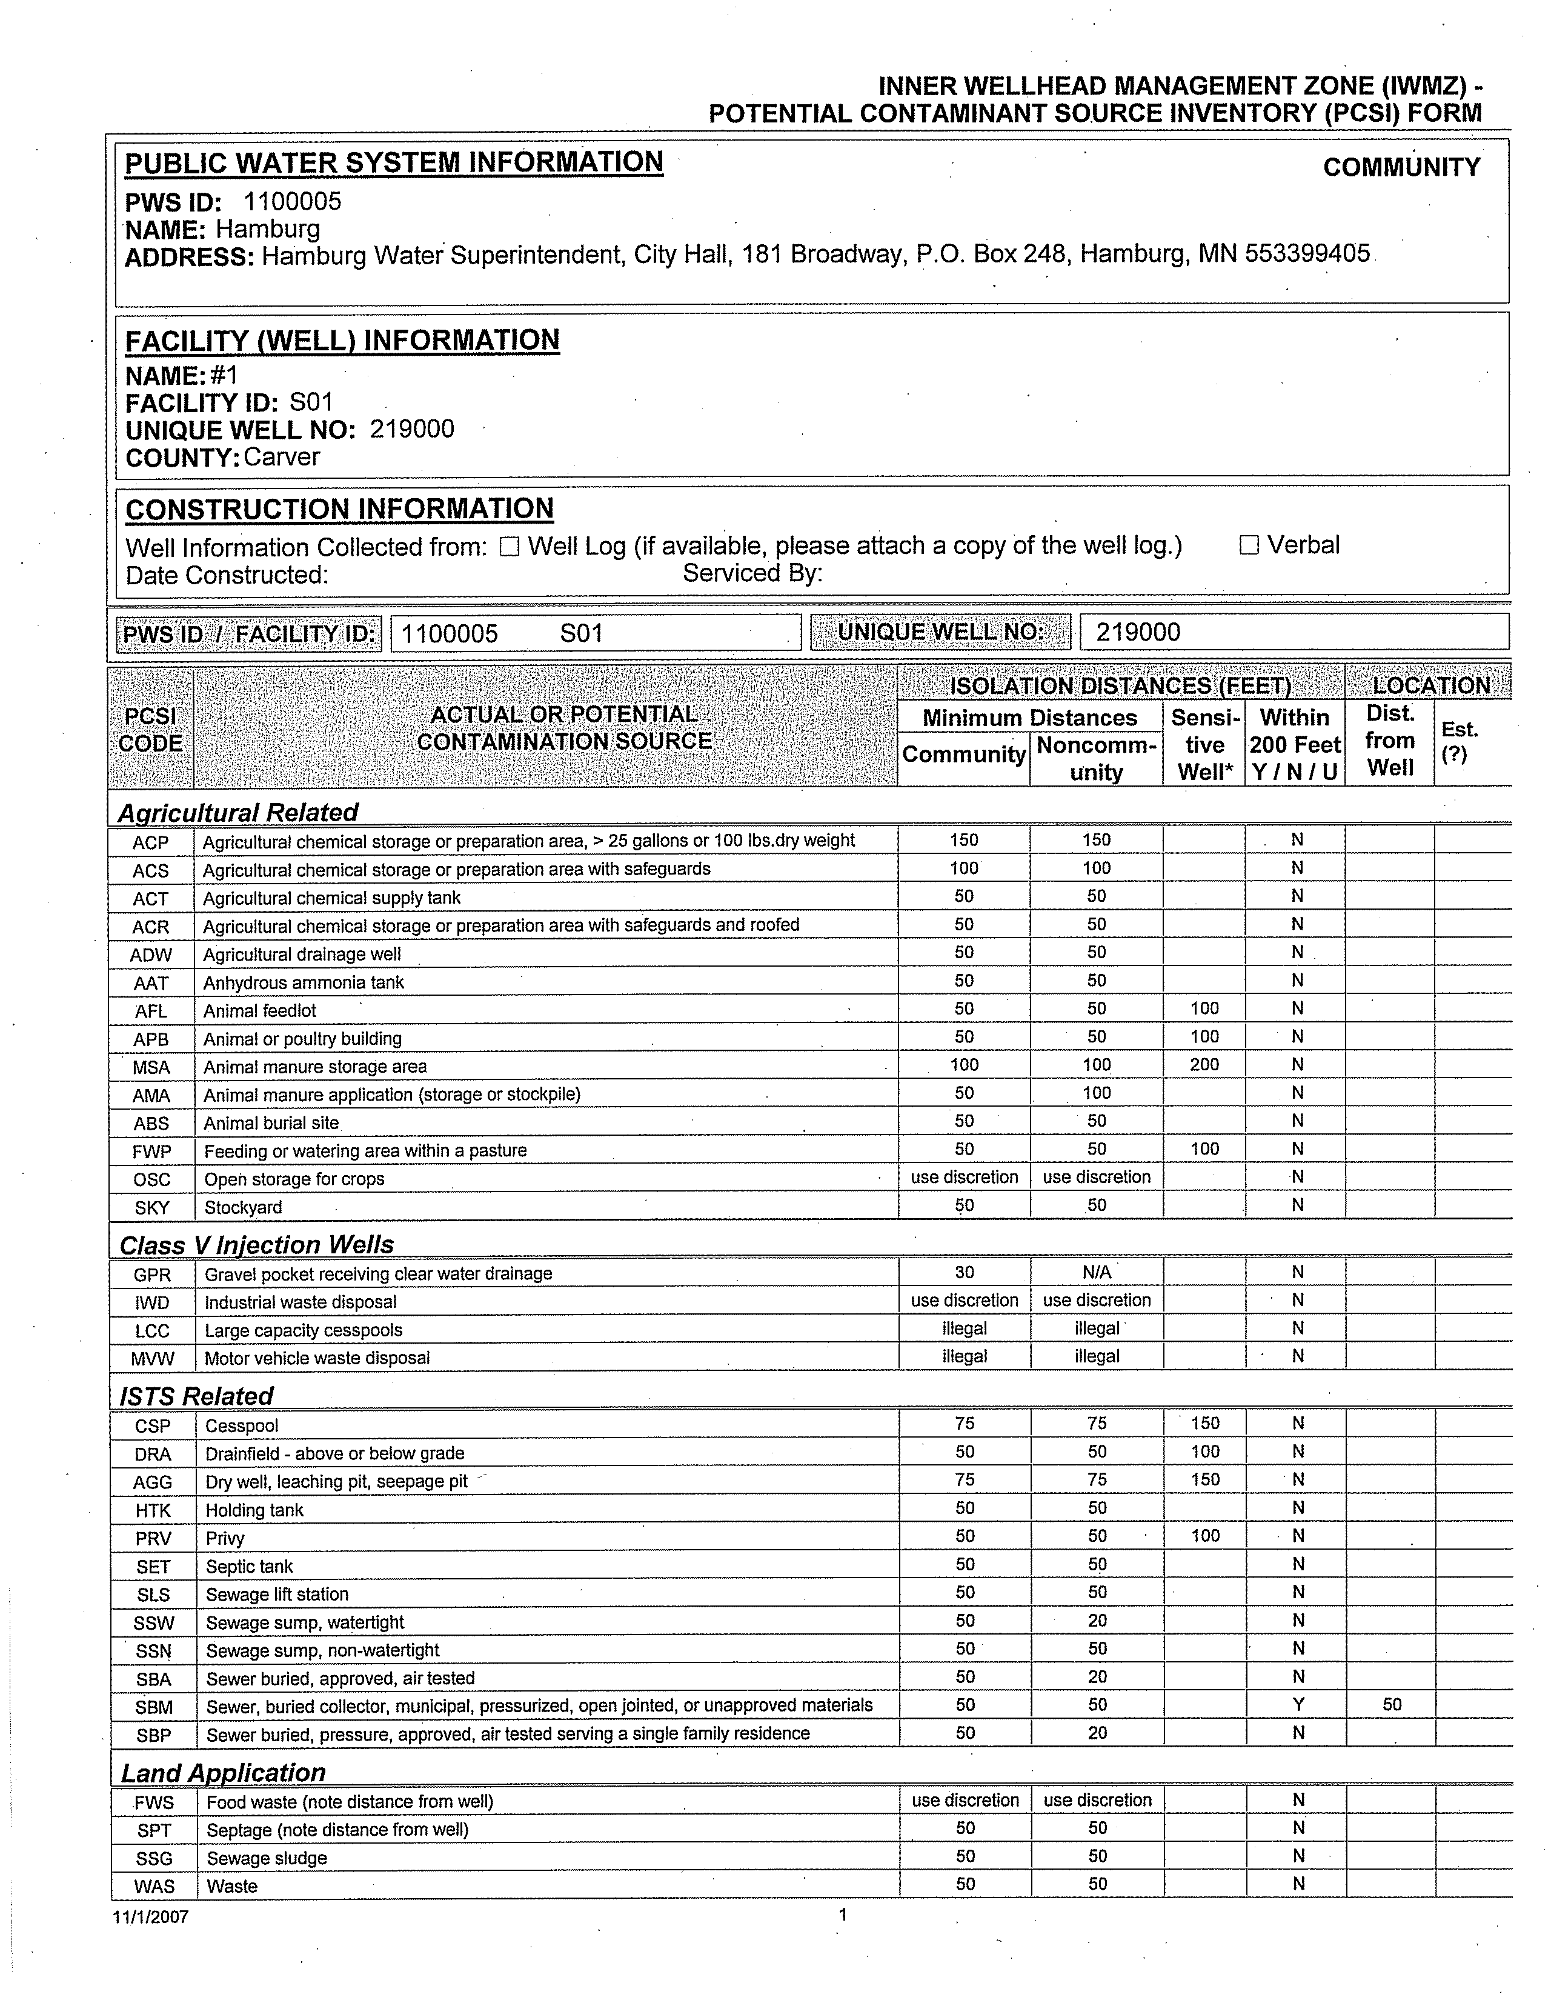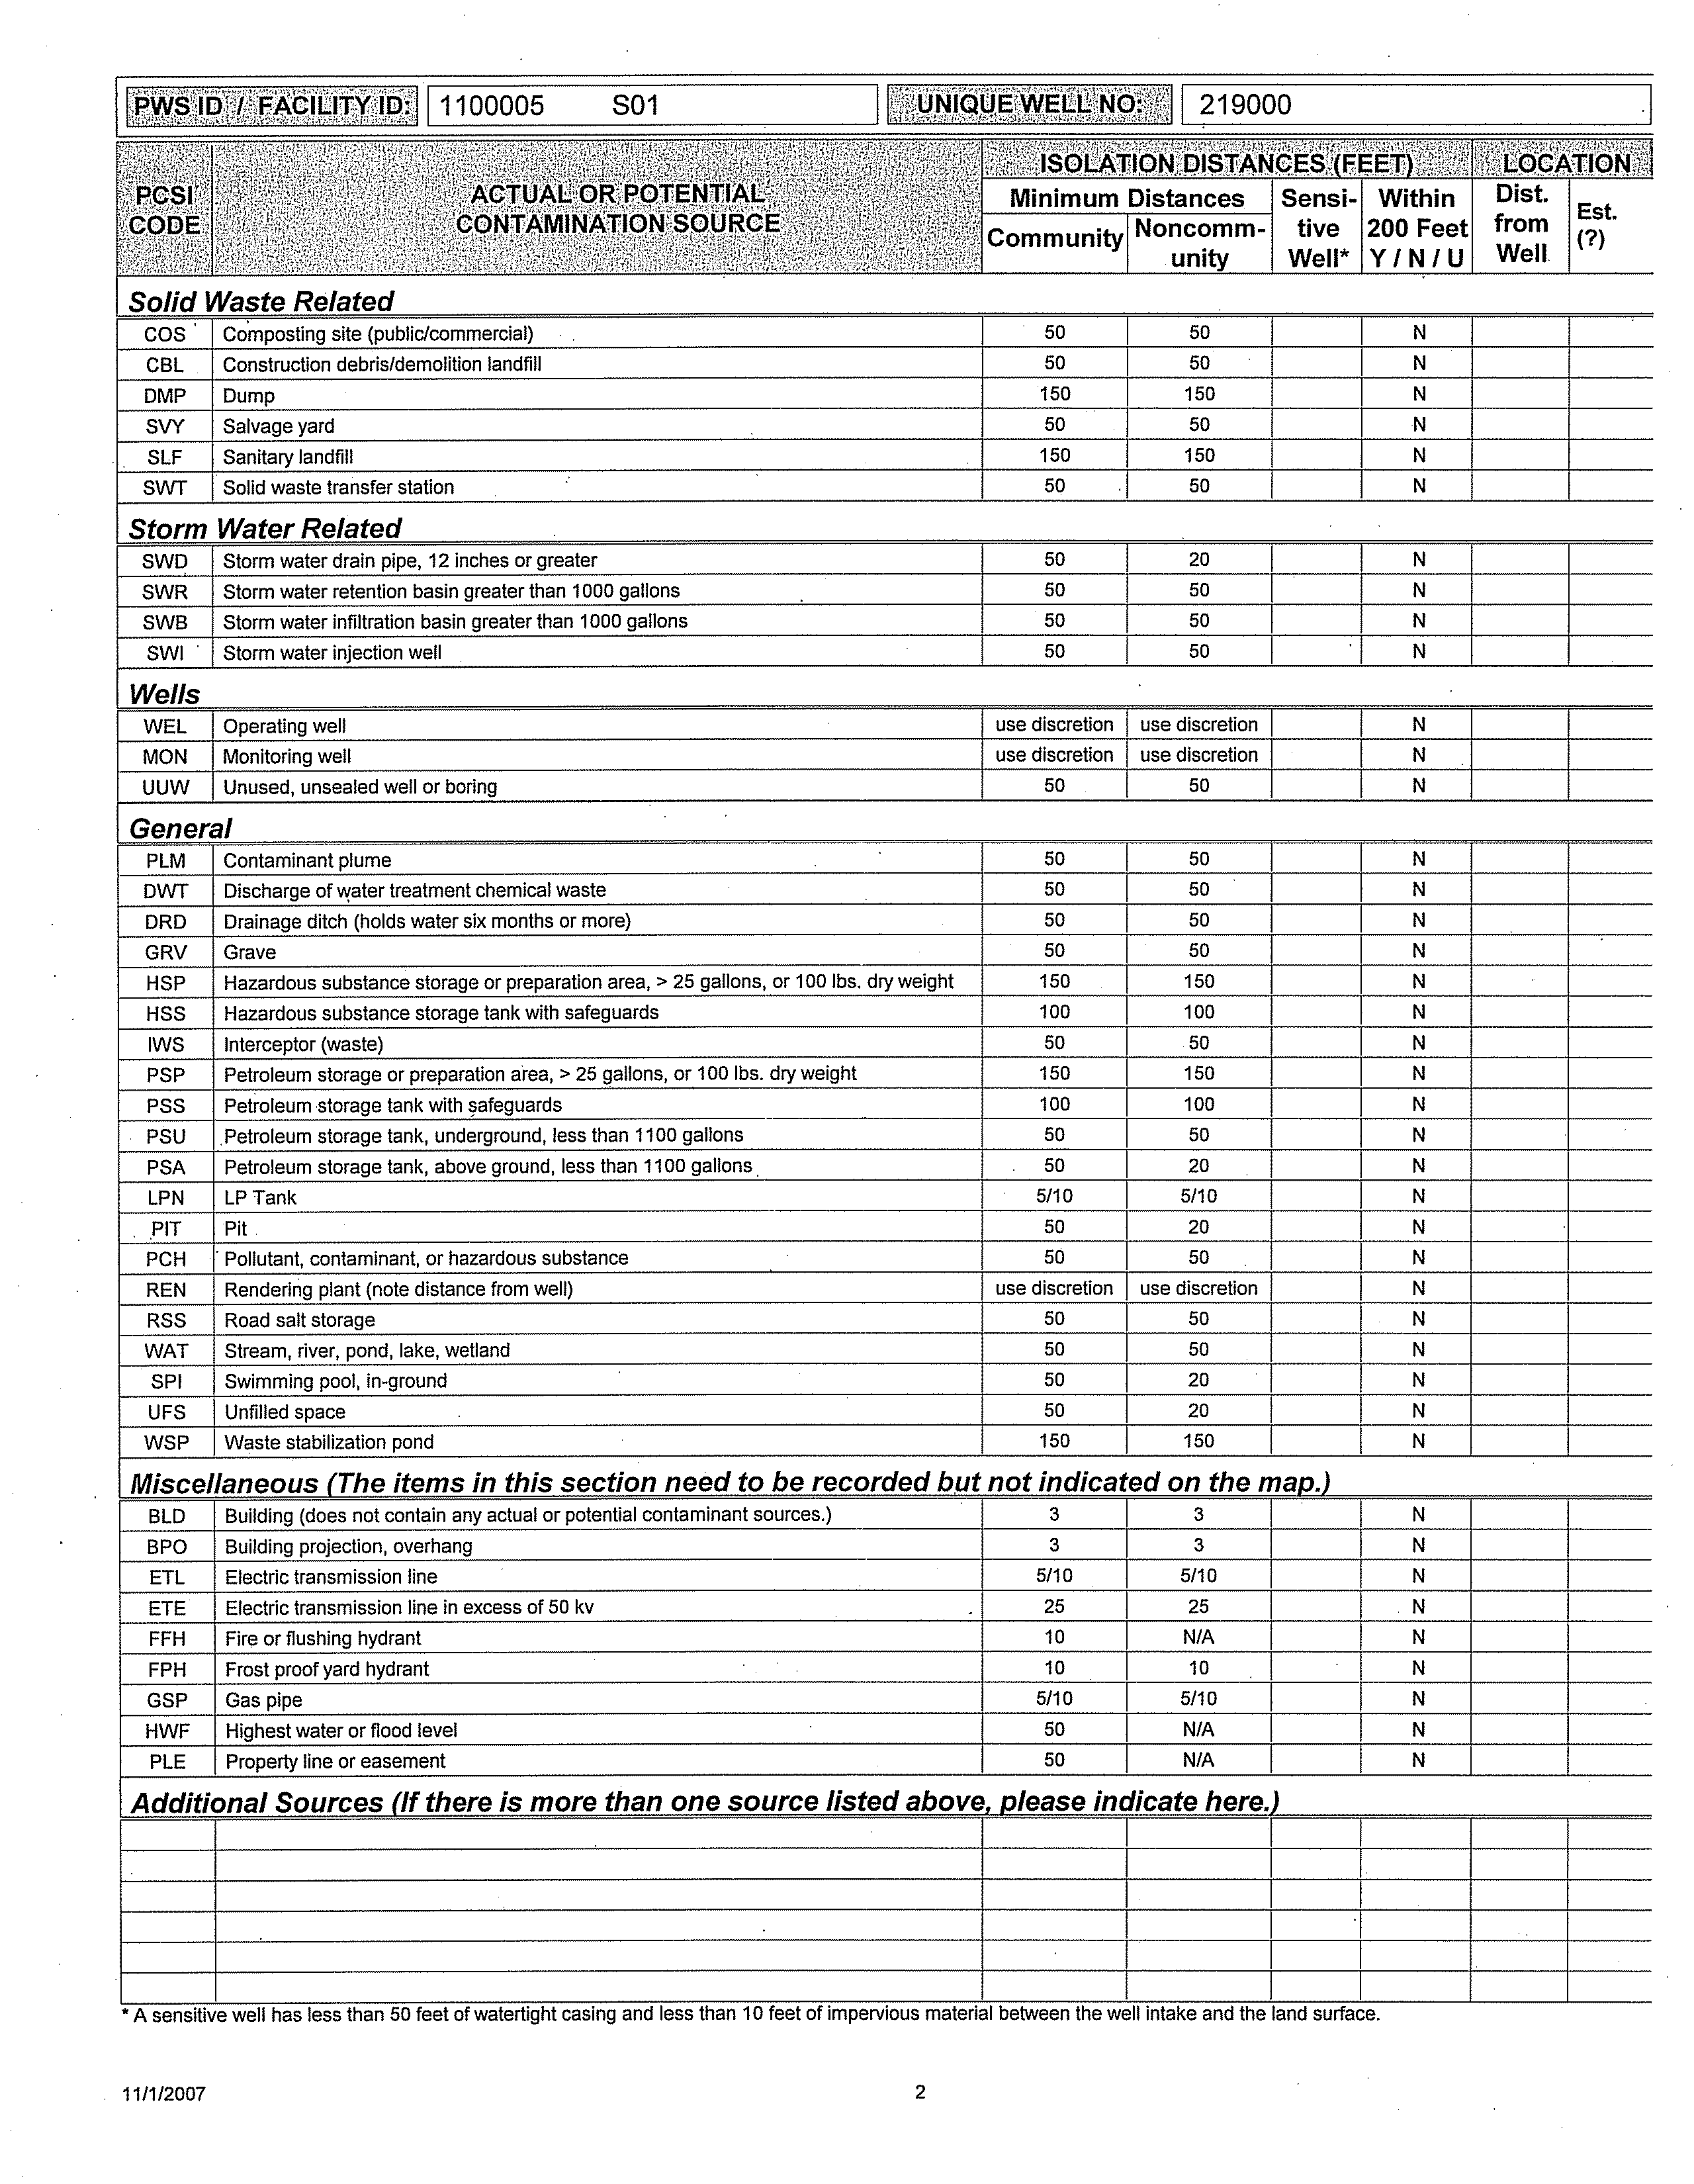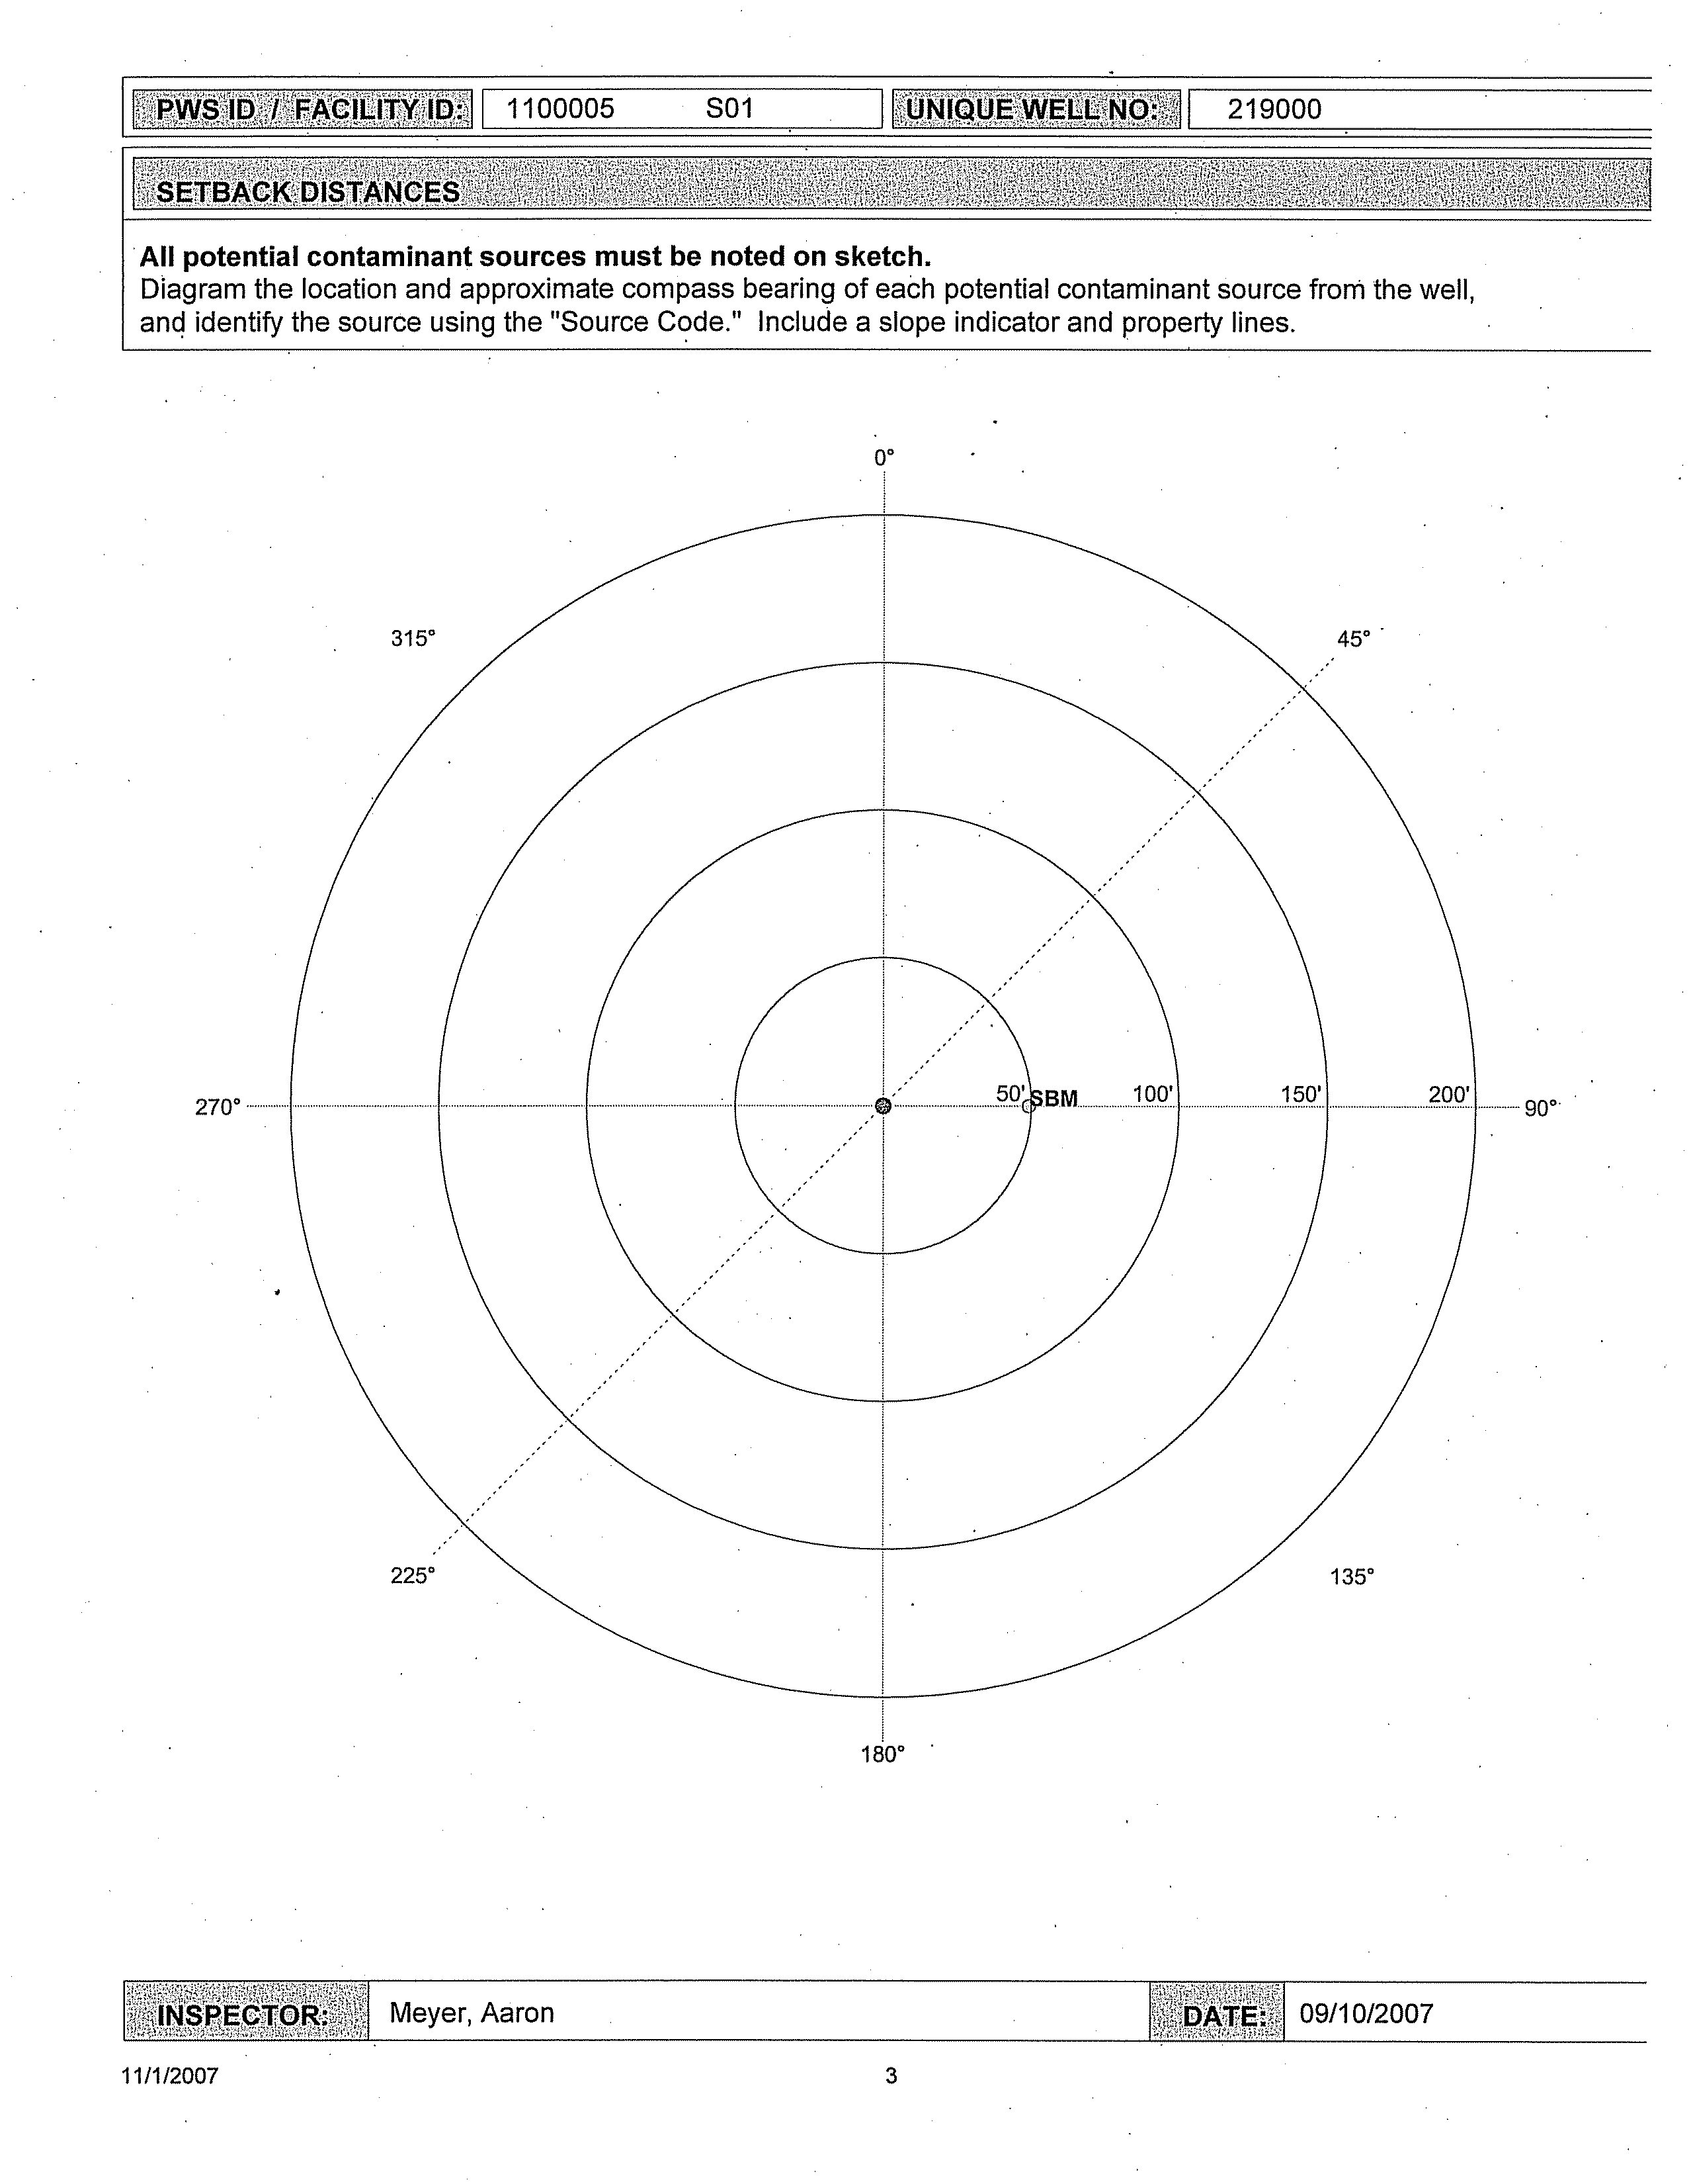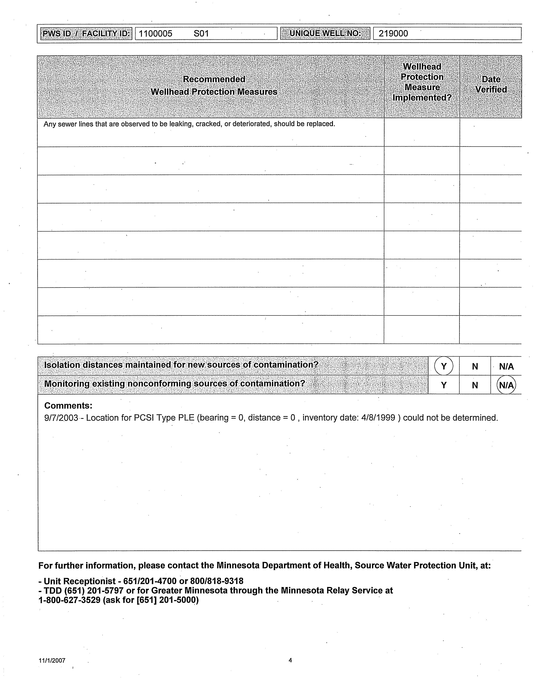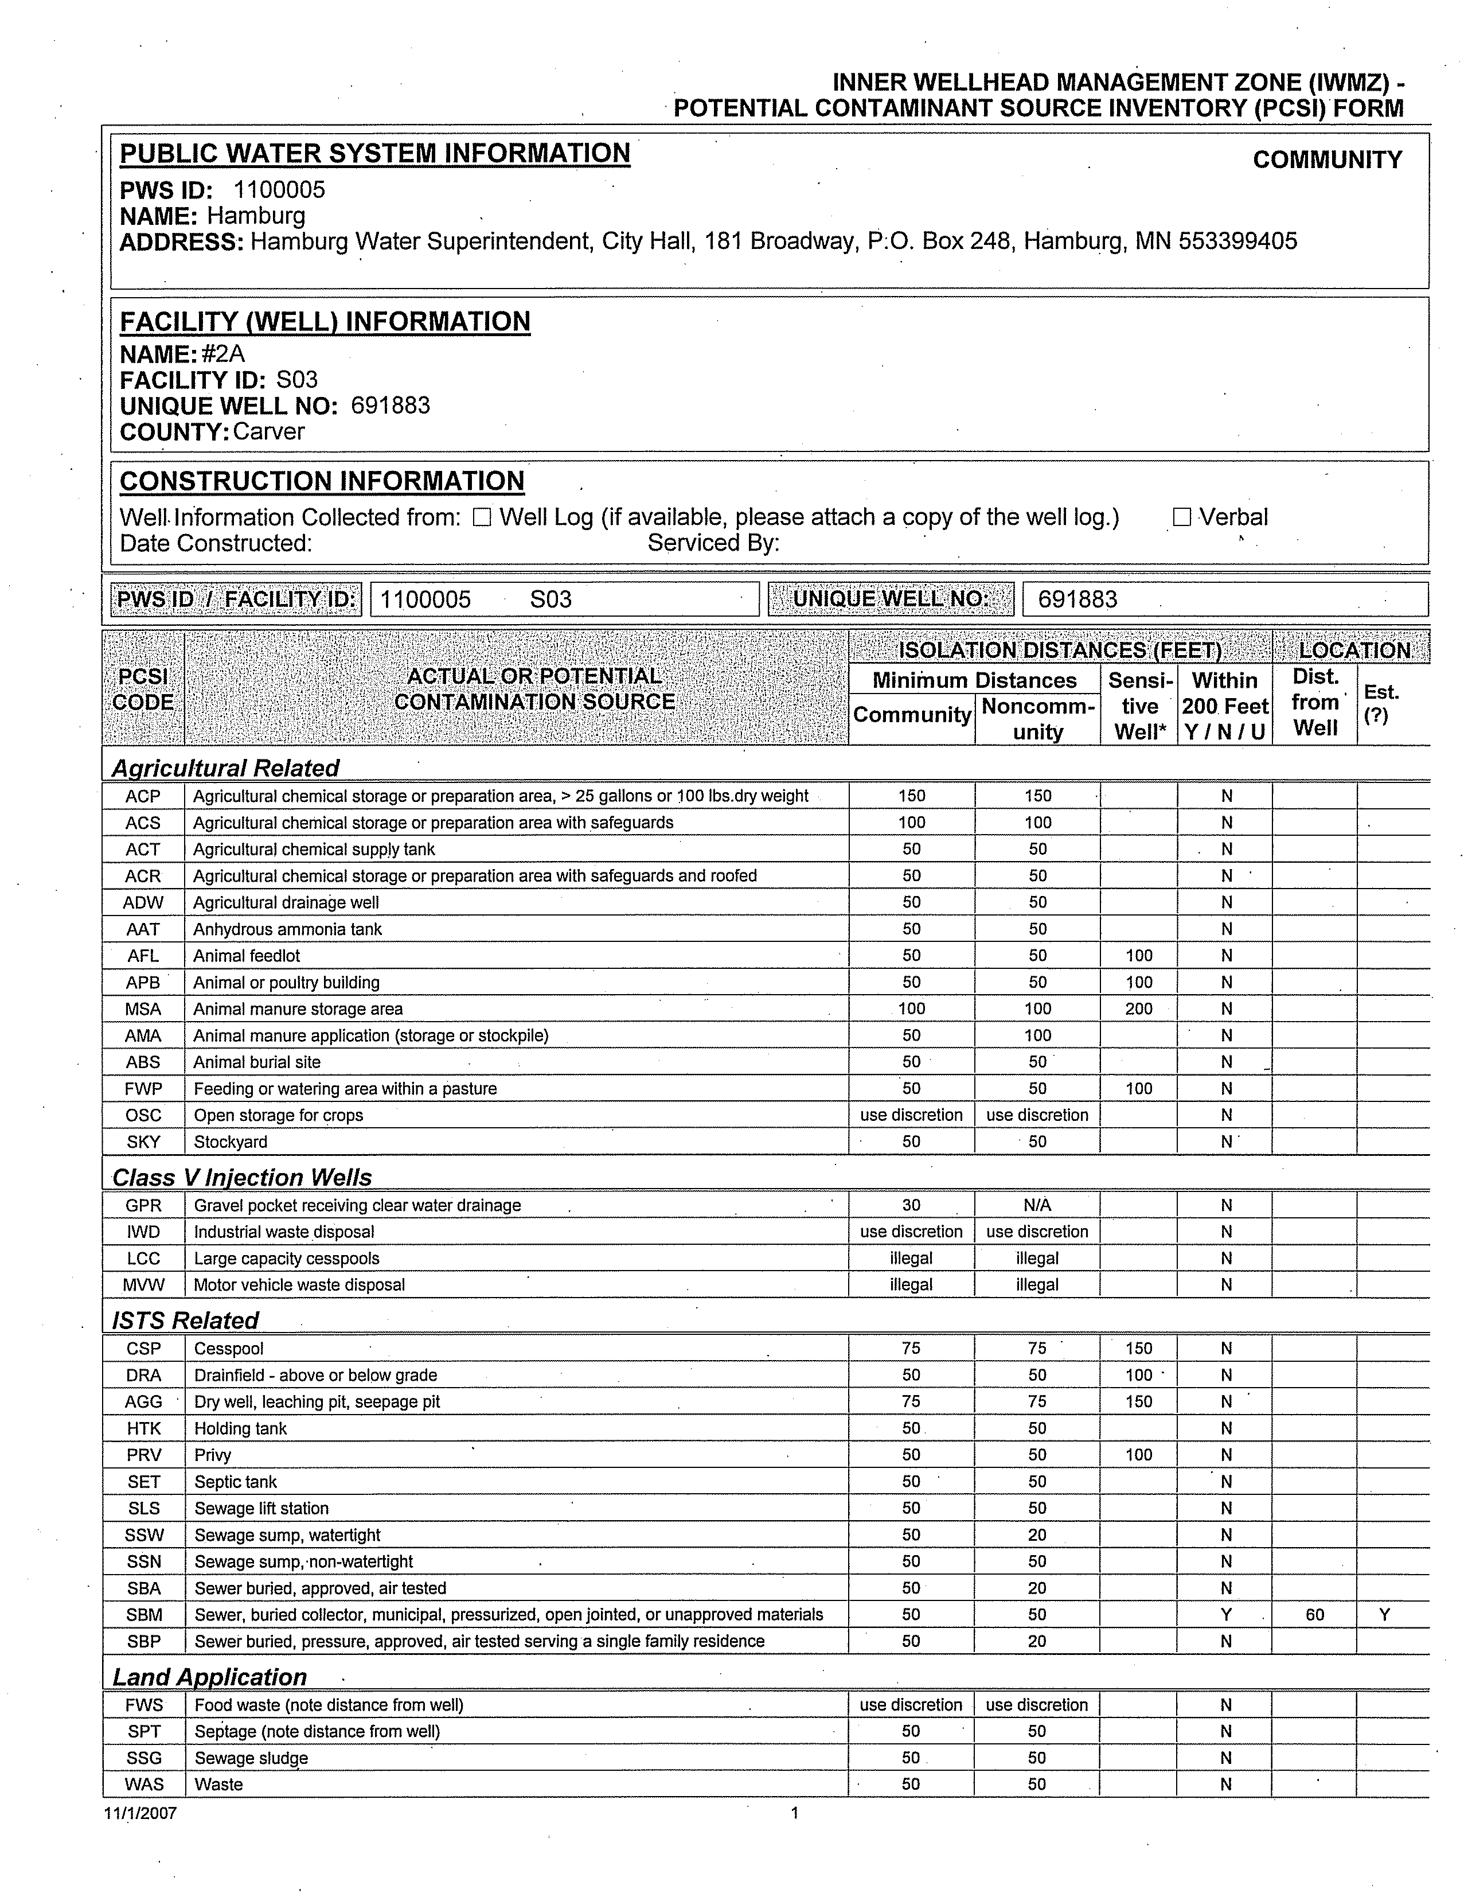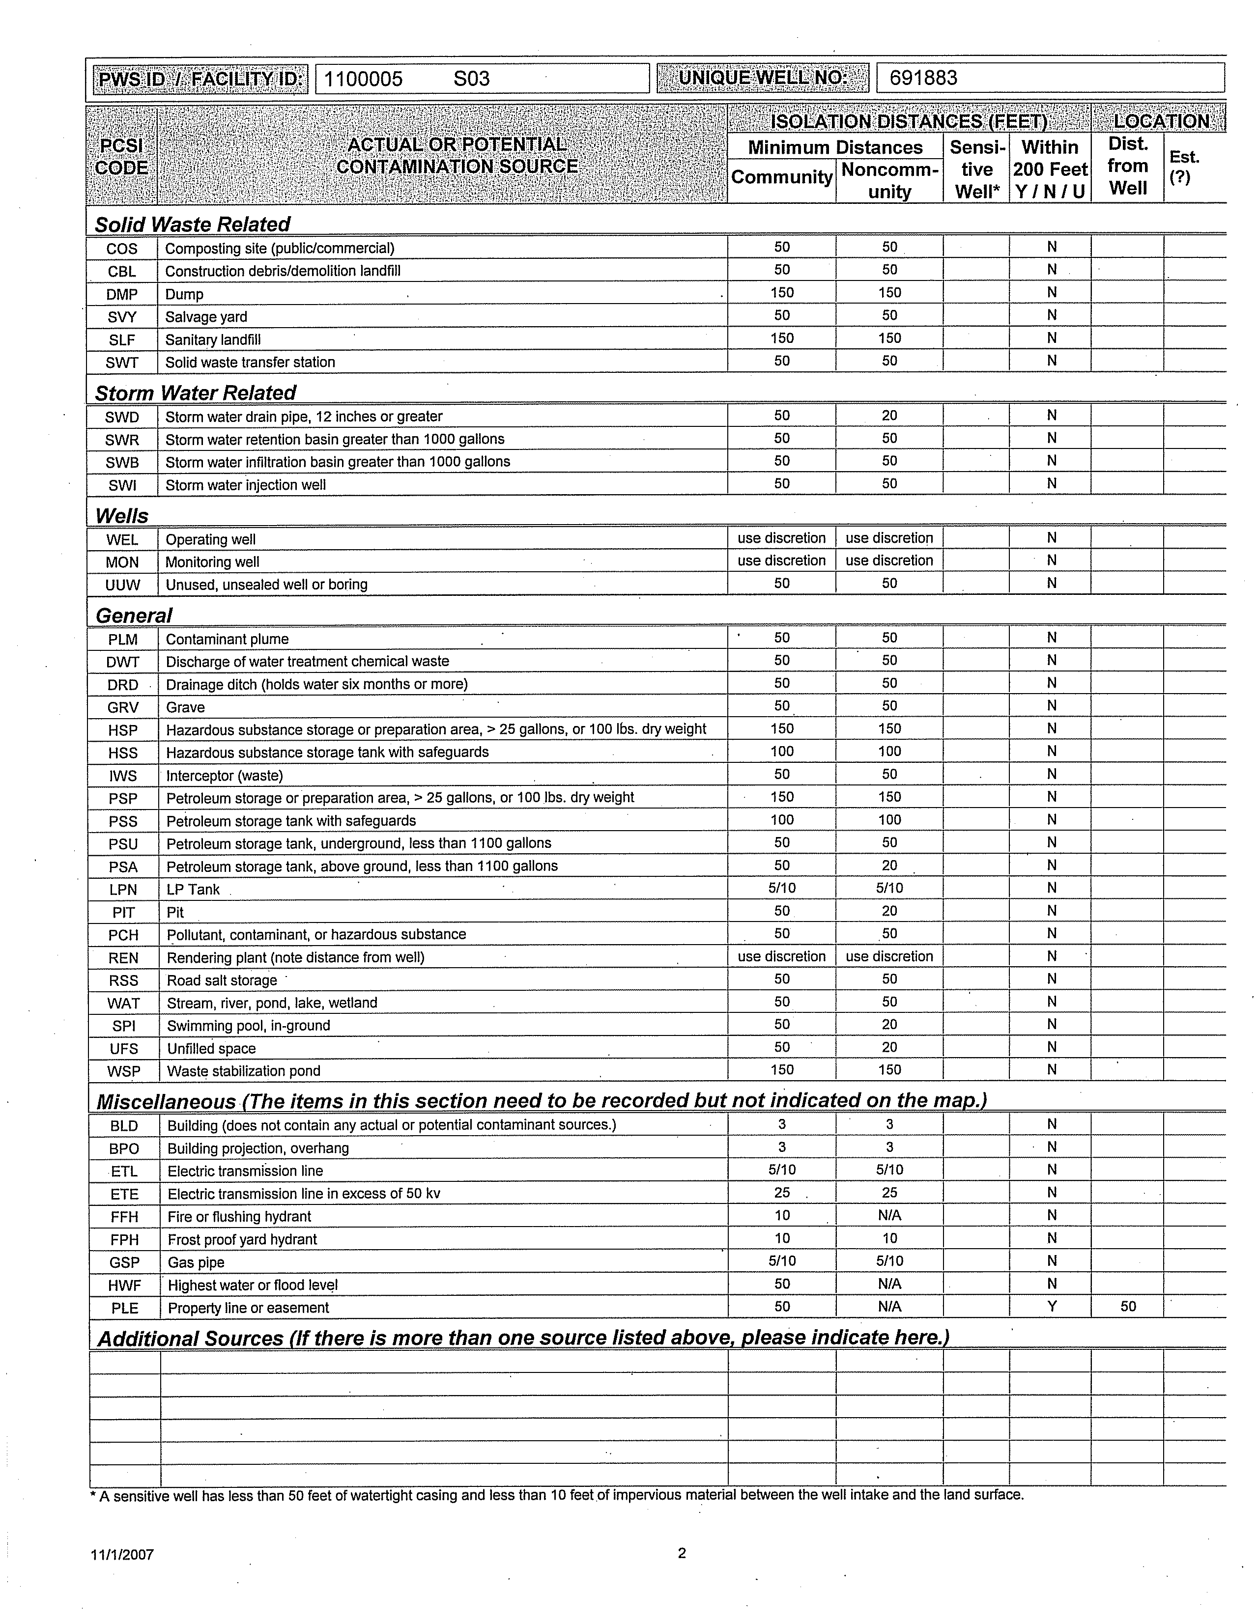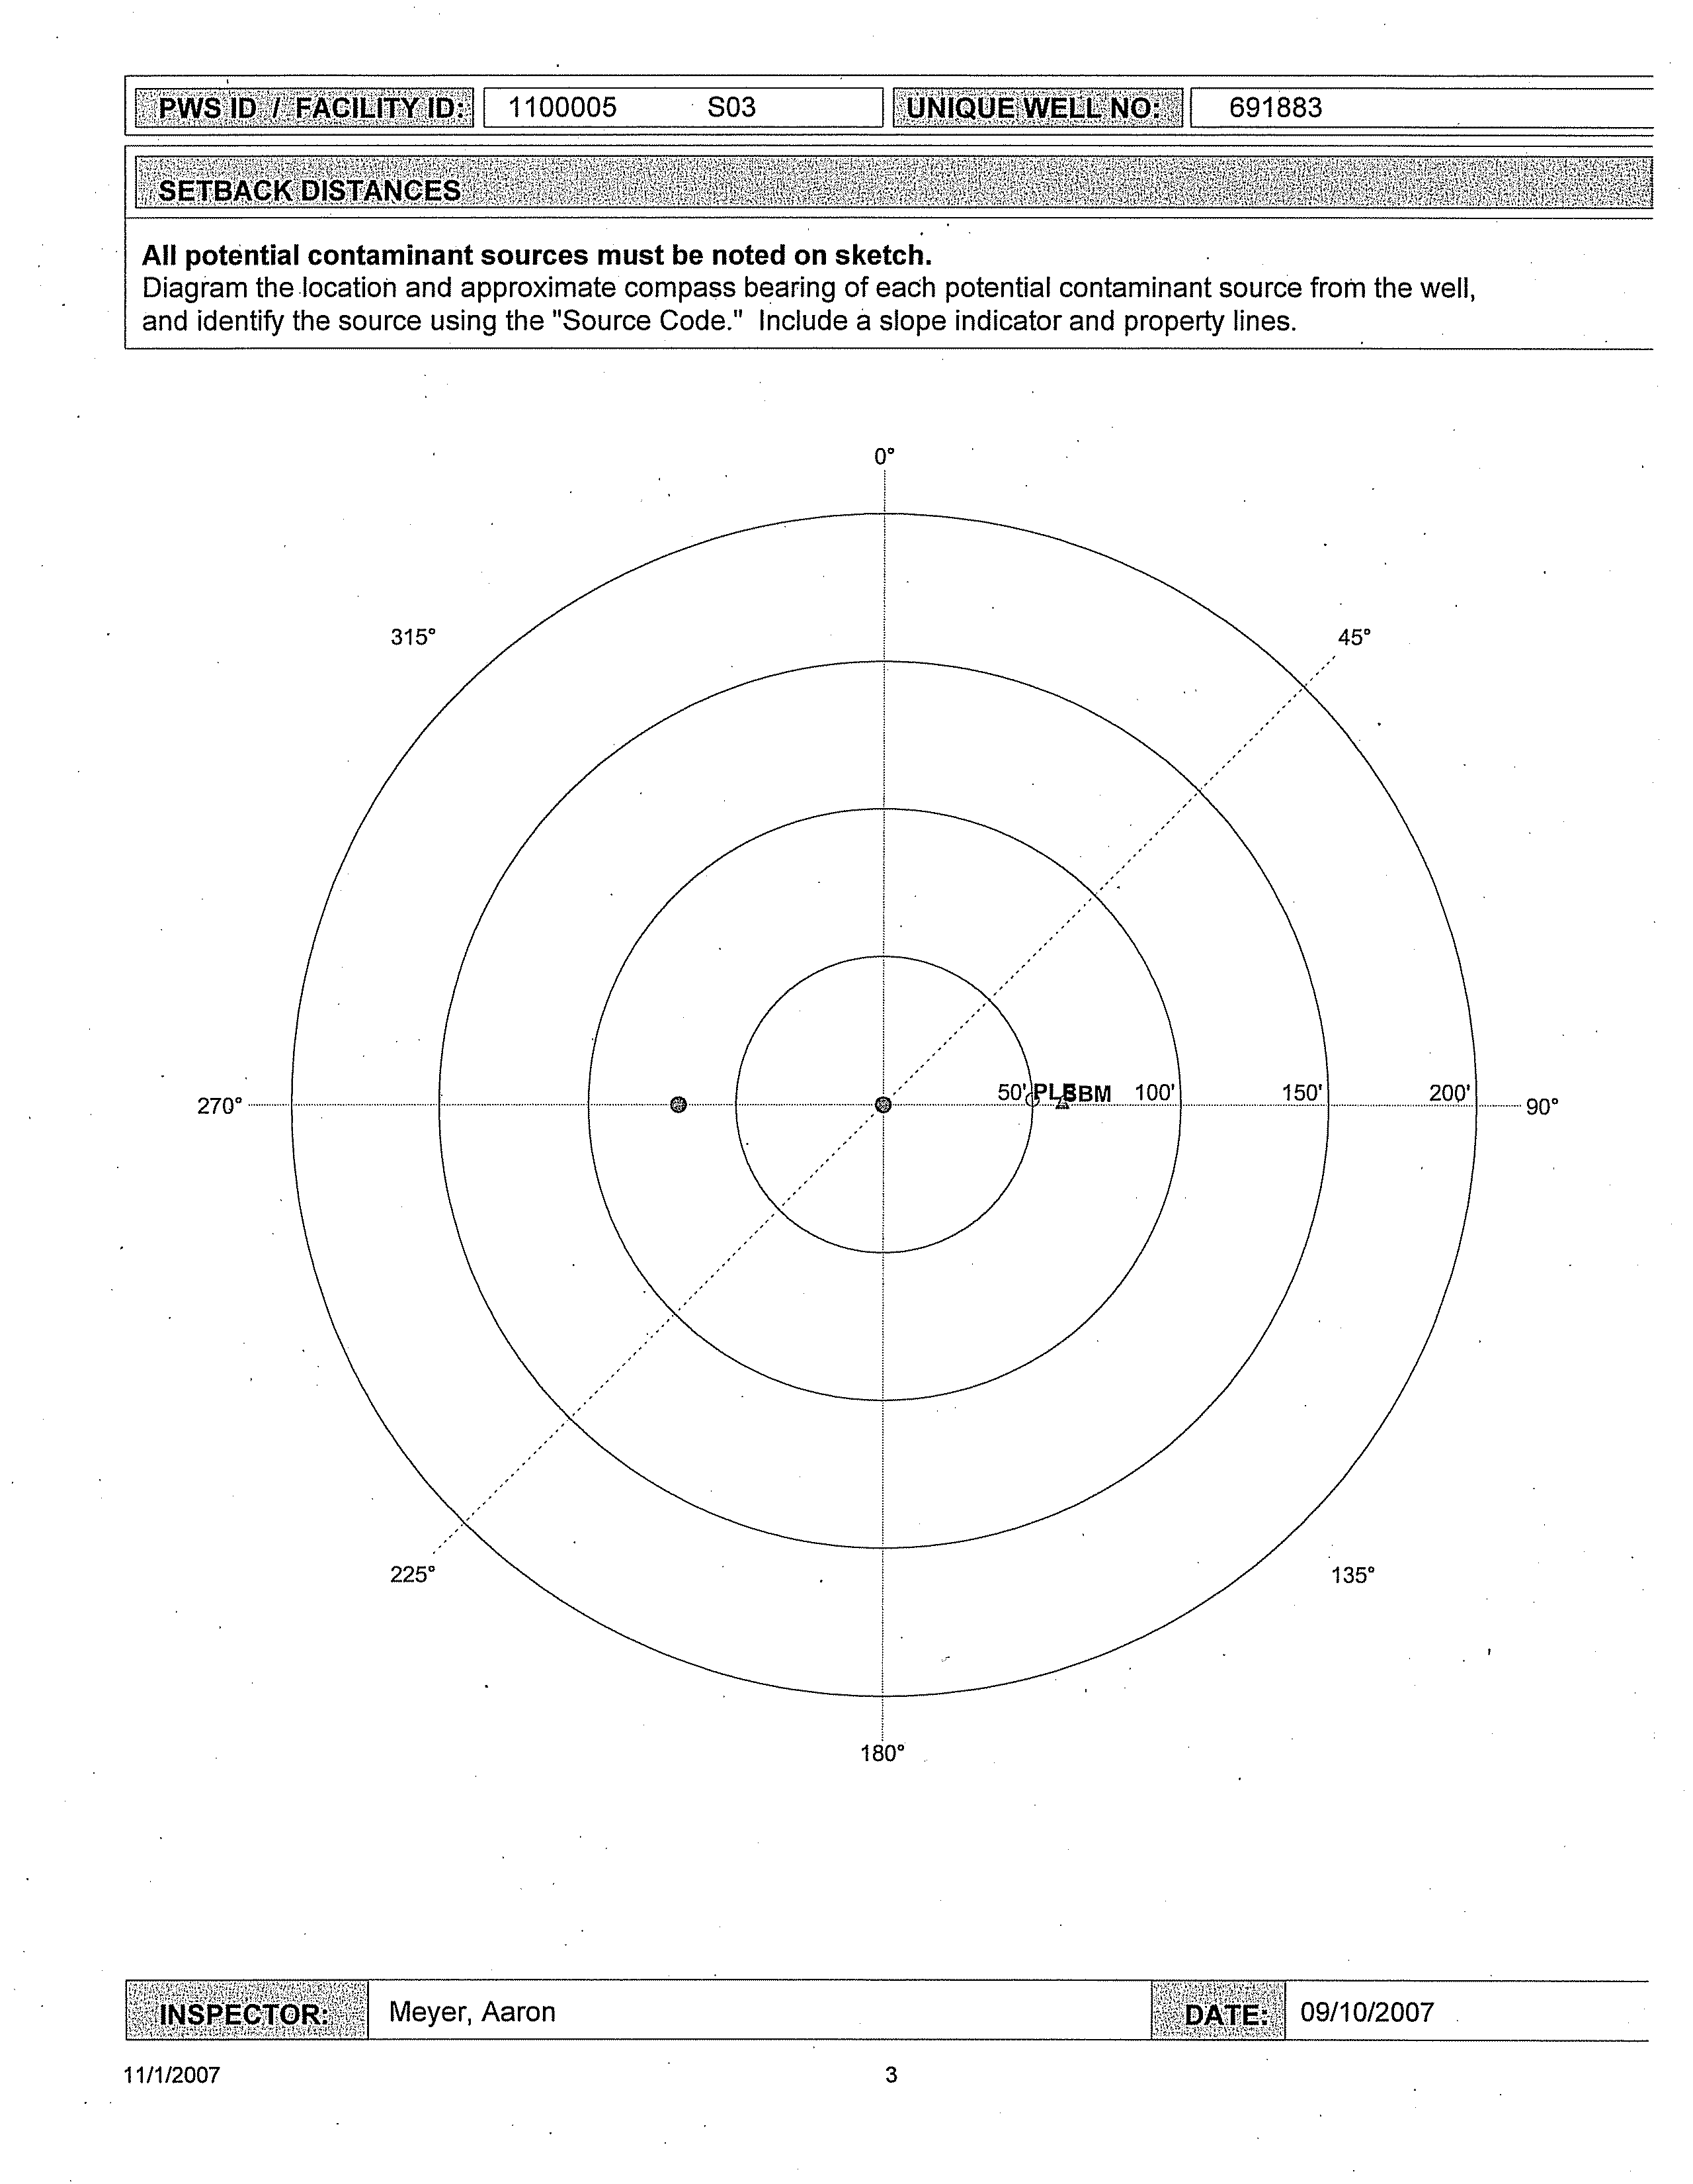
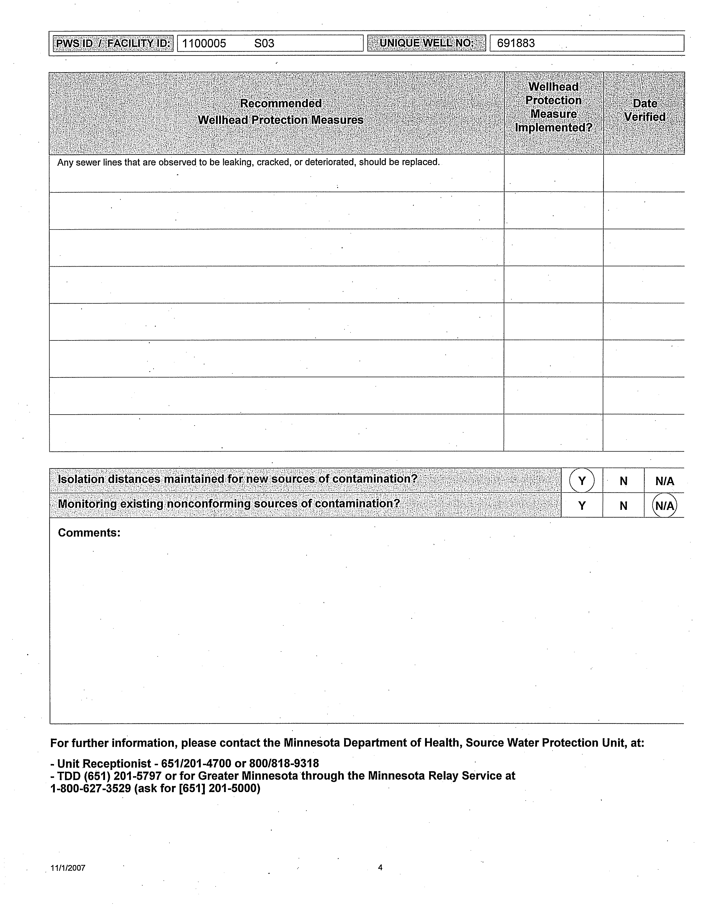
Exhibit 3 – Hamburg Zoning Map

Exhibit #4 - City of Hamburg Ordinance

TITLE V: PUBLIC WORKS

CHAPTER 51: WATER

Section

51.01 Water tap; permit required
51.02 Tap permit; application and fee
51.03 Permit fee for each building; exception
51.04 Remote meter reader unit required
51.05 Separate connections required
51.06 Building service line; responsibility; leaks
51.07 Unauthorized use of water
51.08 Connection to outside water supply prohibited
51.09 Restricted use periods

§ 51.01 WATER TAP; PERMIT REQUIRED.

No person, corporation, firm, or entity of any sort shall make or cause to be made any new or additional connection with any water main in the city without first obtaining from the City Council a permit therefor as hereinafter set forth.
(‘82 Code, § 2-601) (Ord. 38, passed - -) Penalty, see § 50.99

§ 51.02 TAP PERMIT; APPLICATION AND FEE.

Application for water connection permits shall be made at the office of the City Clerk-Treasurer. Each application shall be accompanied by a fee in the sum equal to the cost of the water meter and outside reader unit plus 10% of that amount. The City Council shall act on pending applications at the next regular meeting, and in cases where permits are issued, the permit shall specify the manner and conditions under which connections with the water main may be made by the applicant.
(‘82 Code, § 2-602) (Ord. 96, passed 7-13-82)

§ 51.03 PERMIT FEE FOR EACH BUILDING; EXCEPTION.

The above fee or charge shall be paid for each and every water main tapping or connection for each and every lot and from each and every house, dwelling, residence, outhouse, barn, store, hotel, or building of whatsoever name or nature, and whether the same be made directly or indirectly, or through or by means of the connection with the water main or any other lot or house, dwelling, residence, outhouse, barn, store, hotel, or other building. Provided, however, that when more than one building other than dwellings or residences is situated on any lot, piece, or parcel of land, a connection from the building shall be considered as only one connection and only one meter reader charge shall be made.
(‘82 Code, § 2-603) (Ord. 96, passed 7-13-82)

§ 51.04 REMOTE METER READER UNIT REQUIRED.

A remote water meter reading unit shall be installed on an exterior wall or surface, in a location reasonably accessible to municipal employees, for every newly constructed building receiving a municipal water meter. There shall be a remote reading unit installed on an exterior wall or surface, in a location reasonably accessible to municipal employees, for every existing building receiving metered municipal water service, at the time that a water meter is installed or at the time that the existing water meter is replaced, removed, altered, relocated, or changed because of the water meter being inaccessible, in need of repair or adjustment, broken, inoperative, or for any other reason, regardless of liability. The cost of the purchase and installation of the remote reading unit shall be paid by the customer to the municipality upon direction from the City Clerk-Treasurer or Water Superintendent.
(‘82 Code, § 2-604) (Ord. 96, passed 7-13-82)

§ 51.05 SEPARATE CONNECTIONS REQUIRED.

No more than one house or building shall be supplied from one service connection. The Council, or Water Commissioner, or Building Inspector, when authorized to do so by the Council, may waive this requirement upon a finding that a separate service connection to any house or building is impractical. Whenever two or more houses or buildings are supplied from one building service line connected to a public water main, each house, building, or part thereof separately supplied shall have a separate curbstop and a separate meter reader unit.
(‘82 Code, § 2-616) (Ord. 99, passed 10-12-82) Penalty, see § 50.99

§ 51.06 BUILDING SERVICE LINE; RESPONSIBILITY; LEAKS.

(A) Responsibility for building service line. All water building service lines connecting the public water main to the property served, from and including the curbstop shut-off device to its connection with the interior plumbing system and the interior plumbing system of the house or building served, shall be owned by and all expenses of maintaining, repairing, and replacing them shall be borne by the owner of the property served. For the purpose of defining areas of responsibility the identifying curbstop shall be the curbstop closest to the public water main, regardless of the length of the building service line between the curbstop and the property being served, or whether or not the building service line from the above-defined curbstop is on public or private property, or whether or not other curbstops exist within the building service line system.

(B) Repair of leaks. The customer, and also the owner, occupant, or lessee, if not the customer, shall be responsible for repair of any leaks in the building service line as defined in division (A) of this section. If any such leak is not repaired within the time allowed in the notice, after notice to any of them to repair the leak, including notice left at the premises, the Water Superintendent may shut the water off. When the waste of water is great or damage is likely to occur from the leak, the Water Superintendent may turn the water off immediately and thereafter give notice to repair, as provided herein.
(‘82 Code, §§ 2-617, 2-618) (Ord. 99, passed 10-12-82)

§ 51.07 UNAUTHORIZED USE OF WATER.

No person other than an authorized city employee shall take water from a fire hydrant, from a city water tank filling station, or from any other city facility without first obtaining authority to do so from the Water Superintendent.
(‘82 Code, § 2-619) (Ord. 99, passed 10-12-82) Penalty, see § 50.99

§ 51.08 CONNECTION TO OUTSIDE WATER SUPPLY PROHIBITED.

No person shall connect any water pipe of the city water supply system with any pump, well, or tank that is connected to any other source of water supply. If any such connection exists, the customer, owner, or other person in charge of the premises shall forthwith sever the connection. When any such connection is found, the Water Superintendent may notify the customer, owner, or other person in charge of the premises to sever the connection immediately. If this is not done immediately, the Water Superintendent may turn off the water supply. All cross connections shall be eliminated before city water service is restored to the premises.
(‘82 Code, § 2-620) (Ord. 99, passed 10-12-82) Penalty, see § 50.99

§ 51.09 RESTRICTED USE PERIODS.

Whenever the City Council determines that a shortage of water supply threatens the city water supply, it may, by resolution, limit the times and hours during which city water may be used for sprinkling, air conditioning, irrigation, car washing, and other specified uses. After publication of the resolution, or after delivery of the resolution to the affected premises, three days after mailing the resolution to each affected customer, or after three days after the posting of the resolution in three or more public places, no person shall use or permit water to be used in violation of the restrictions imposed in the resolution. Any person who does so may be charged an excess use charge, as the City Council may determine by resolution. Continued violation shall be cause for discontinuation of water service in accordance with the procedures specified for discontinuance of service for a leak found upon the customer’s premises, as found in § 51.06(B) of this code.
(‘82 Code, § 2-621) (Ord. 99, passed 10-12-82) Penalty, see § 50.99

Exhibit #5 - Local Units of Government

Minnesota Department of Health
Attn: Terry Bovee
410 Jackson, Suite 400
Mankato, MN 56001

Carver County SWCD
219 E Frontage Road
Waconia, MN 55387-1862

Carver County
Attn: Paul Moline
600 E Fourth Street
Chaska, MN 55318-2158

Metropolitan Council
Attn: Chris Elvrum
390 Robert St. North
St. Paul, MN 55101-1805

Carver County Board Chairperson
Government Center
600 East 4th Street
Chaska, MN 55318

Norwood Young America Township
Lothar Wolter Jr. – Twp. Clerk
13325 Co. Rd 33
Norwood Young America, MN 55368

Exhibit #6 - 2006 Consumer Confidence Report

PWSID: 1100005

City of Hamburg
2006 Drinking Water Report
The City of Hamburg is issuing the results of monitoring done on its drinking water for the period from January 1 to December 31, 2006. The purpose of this report is to advance consumers' understanding of drinking water and heighten awareness of the need to protect precious water resources.
Source of Water
The City of Hamburg provides drinking water to its residents from a groundwater source: two wells that are 620 feet deep, that draw water from the Franconia-Ironton-Galesville aquifer.
The water provided to customers may meet drinking water standards but the Minnesota Department of Health has determined that one or more of the sources of water is potentially susceptible to contamination. If you wish to obtain the entire source water assessment regarding your drinking water, please call 651-201-0800 or 1-800-818-9318 (and press 5) during normal business hours. Also, you can view it on line at www.health.state.mn.us/divs/eh/water/swp/swa.
Please contact Dennis Byerly at (952) 467-3046 or Jeremy Gruenhagen at (952) 467-3232 or by writing to the City of Hamburg: 181 Broadway Ave., Hamburg, MN 55339 if you have any questions about the City of Hamburg’s drinking water or would like information about opportunities for public participation in decisions that may affect the quality of the water.
Results of Monitoring
No Contaminants were detected at levels that violated federal drinking water standards. However, some contaminants were detected in trace amounts that were below legal limits. The table that follows shows the contaminants that were detected in trace amounts last year. (Some contaminants are samples less frequently than once a year; as a result, not all contaminants were sampled for 2006. If any of these contaminants were detected the last time they were sampled for, they are included in the table along with the date that the detection occurred.)
Key to abbreviations:
MCLG—Maximum Contaminant Level Goal: The level of a contaminant in drinking water below which there is no known or expected risk to health. MCLGs allow for a margin of safety.
MCL—Maximum Contaminant Level: The highest level of a contaminant that is allowed in drinking water. MCLs are set as close to the MCLGs as feasible using the best available treatment technology.
AL—Action Level: The concentration of a contaminant which, if exceeded, triggers treatment or other requirement which a water system must follow.
90th Percentile Level—This is the value obtained after disregarding 10 percent of the samples taken that had the highest levels. (For example, in a situation in which 10 samples were taken, the 90th percentile level is determined by disregarding the highest result, which represents 10 percent of the samples.) Note: In situations in which only 5 samples are taken, the average of the two with the highest levels is taken to determine the 90th percentile level.

pCi/1—PicoCuries per liter (a measure of radioactivity).
ppb—Parts per billion, which can also be expressed as micrograms per liter (ug/1).
ppm—Parts per million, which can also be expressed as milligrams per liter (mg/1).
N/A—Not Applicable (does not apply).

Contaminant  (units) | MCLG | MCL | Level Found |  | Typical Source of Contaminant
Contaminant  (units) | MCLG | MCL | Range  (2006) | Average  /Result* | Typical Source of Contaminant
Antimony (ppb)  (04/07/2005) | 6 | 6 | N/A | .88 | Discharge from petroleum refineries; Fire retardants; Ceramics; Electronics; Solder.
Arsenic (ppb)  (04/07/2005) | 0 | 10 | N/A | 1.56 | Erosion of natural deposits; Runoff  from orchards; Runoff from glass and electronics production wastes.  electronics production wastes.
Barium (ppm)  (04/07/2005) | 2 | 2 | N/A | .03 | Discharge of drilling wastes;  Discharge from metal refineries;  Erosion of natural deposits.
Fluoride (ppm) | 4 | 4 | .89-1.1 | 1.07 | State of Minnesota requires all  municipal water systems to add  fluoride to the drinking water to  promote strong teeth; Erosion of  natural deposits; Discharge from  fertilizer and aluminum factories.
Nitrate (as Nitrogen) (ppm) | 10 | 10 | .14-.8 | .8 | Runoff from fertilizer use;  Leaching from septic tanks,  sewage; Erosion of natural deposits
Nitrate (as  Nitrogen) (ppm)  (07/27/2005) | 1 | 1 | N/A | .03 | Runoff from fertilizer use; Leaching  from septic tanks, sewage; Erosion of natural deposits.
Xylenes (ppm) | 10 | 10 | N/A | .001 | Discharge from petroleum factories; Discharge from chemical factories.

Contaminant (units) | Level Found |  | Typical Source of Contaminant
Contaminant (units) | Range  (2006) | Average/  Result* | Typical Source of Contaminant
Radon (pCi/1) (12/09/2005) | N/A | 728 | Erosion of natural deposits.
*This is the value used to determine compliance with federal standards. It sometimes is the highest value detected and sometimes is an average of all the detected values. If it is an average, it may contain sampling results from the previous year.
Radon is a radioactive gas which is naturally occurring in some groundwater. It poses a lung cancer risk when gas is released from water into air (as occurs during showering, bathing, or washing dishes or clothes) and a stomach cancer risk when it is ingested. Because radon in indoor air poses a much greater health risk than radon in drinking water, an Alternative Maximum Contaminant Level (AMCL) of 4,000 PicoCuries per liter may apply in states that have adopted an Indoor Air Program, which compels citizens, homeowners, schools, and communities to reduce the radon threat from indoor air. For states without such a program, the Maximum Contaminant Level (MCL) of 300 pCi/1 may apply. Minnesota plans to adopt an Indoor Air Program once the Radon Rule is finalized.

Contaminant  (units) | MCLG | AL | 90%  Level | # sites  over AL | Typical Source of Contaminant
Copper (ppm)  (07/27/2005) | N/A | 1.3 | .3 | 0 out of 10 | Corrosion of household plumbing  systems; Erosion of natural deposits.
Lead (ppb)  (07/27/2005) | N/A | 15 | 11 | 0 out of 10 | Corrosion of household plumbing  systems; Erosion of natural deposits.
Some contaminants do not have Maximum Contaminant Levels established for them. These "unregulated contaminants" are assessed using state standards known as health risk limits to determine if they pose a threat to human health. If unacceptable levels of an unregulated contaminant are found, the response is the same as if an MCL has been exceeded; the water system must inform its customers and take other corrective actions. In the table that follows are the unregulated contaminants that were detected:

Contaminant (units) | Level Found |  | Typical Source of Contaminant
Contaminant (units) | Range  (2006) | Average/  Result | Typical Source of Contaminant
Nickel (ppb) (04/07/2005) | N/A | 10.1 | Erosion of natural deposits; Discharge from industrial sites.
Sodium (ppm) (04/07/2005) | N/A | 36 | Erosion of natural deposits.
Sulfate (ppm) (04/07/2005) | N/A | 140 | Erosion of natural deposits.
Compliance with National Primary Drinking Water Regulations
The sources of drinking water (both tap water and bottled water) include rivers, lakes, streams, ponds, reservoirs, springs, and wells. As water travels over the surface of the land or through the ground, it dissolves naturally-occurring minerals and, in some cases, radioactive material, and can pick up substances resulting from the presence of animals or from human activity.
Contaminants that may be present in source water include:
Microbial contaminants, such as viruses and bacteria, which may come from sewage treatment plants, septic systems, agricultural livestock operations, and wildlife.
Inorganic contaminants, such as salts and metals, which can be naturally-occurring or result from urban stormwater runoff, industrial or domestic wastewater discharges, oil and gas production, mining, or farming.
Pesticides and herbicides, which may come from a variety of sources such as agriculture, urban stormwater runoff, and residential uses.
Organic chemical contaminants, including synthetic and volatile organic chemicals, which are by-products of industrial processes and petroleum production, and can also come from gas stations, urban stormwater runoff, and septic systems.
Radioactive contaminants, which can be naturally-occurring or be the result of oil and gas production and mining activities.
In order to ensure that tap water is safe to drink, the U.S. Environmental Protection Agency (EPA) prescribes regulations which limit the amount of certain contaminants in water provided by public water systems. Food and Drug Administration regulations establish limits for contaminants in bottled water which must provide the same protection for public health.
Drinking water, including bottled water, may reasonably be expected to contain at least small amounts of some contaminants. The presence of contaminants does not necessarily indicate that water poses a health risk. More information about contaminants and potential health effects can be obtained by calling the Environmental Protection Agency's Safe Drinking Water Hotline at 1-800-426-4791.
Some people may be more vulnerable to contaminants in drinking water than the general population. Immuno-compromised persons such as persons with cancer undergoing chemotherapy, persons who have undergone organ transplants, people with HIV/AIDS or other immune system disorders, some elderly, and infants can be particularly at risk from infections. These people should seek advice about drinking water from their health care providers. EPA/CDC guidelines on appropriate means to lessen the risk of infection by Crytosporidium are available from the Safe Drinking Water Hotline at 1-800-426-4791.
The City Water Improvement Project is complete. The City now has two (2) new Water Wells and a new Water Treatment Plant to better meet demand and federal drinking water standards.
This Consumer Report (2006 Drinking Water Report) for the City of Hamburg is not being distributed to all customers but is available upon request. You can request a copy by calling City Offices at (952) 467-3232.
Exhibit #7 - Land Cover Map

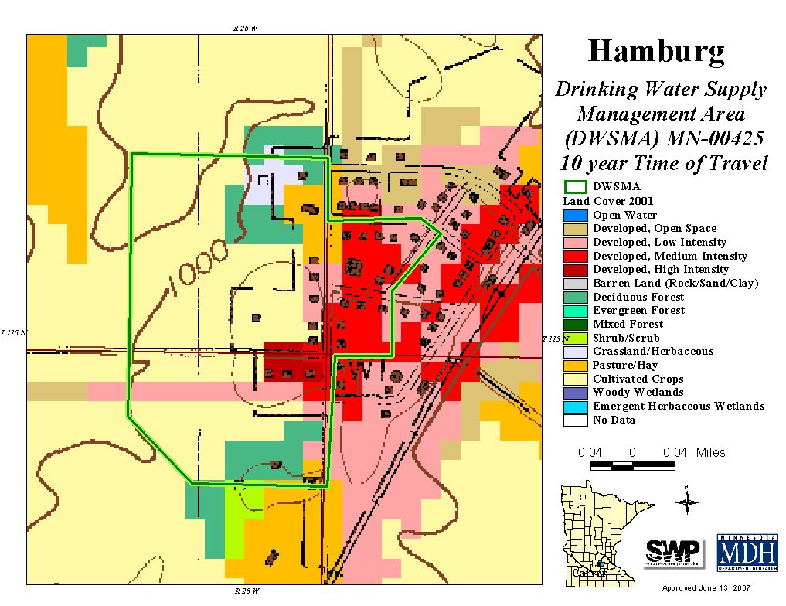

Exhibit #8 - City of Hamburg Old Municipal Wells

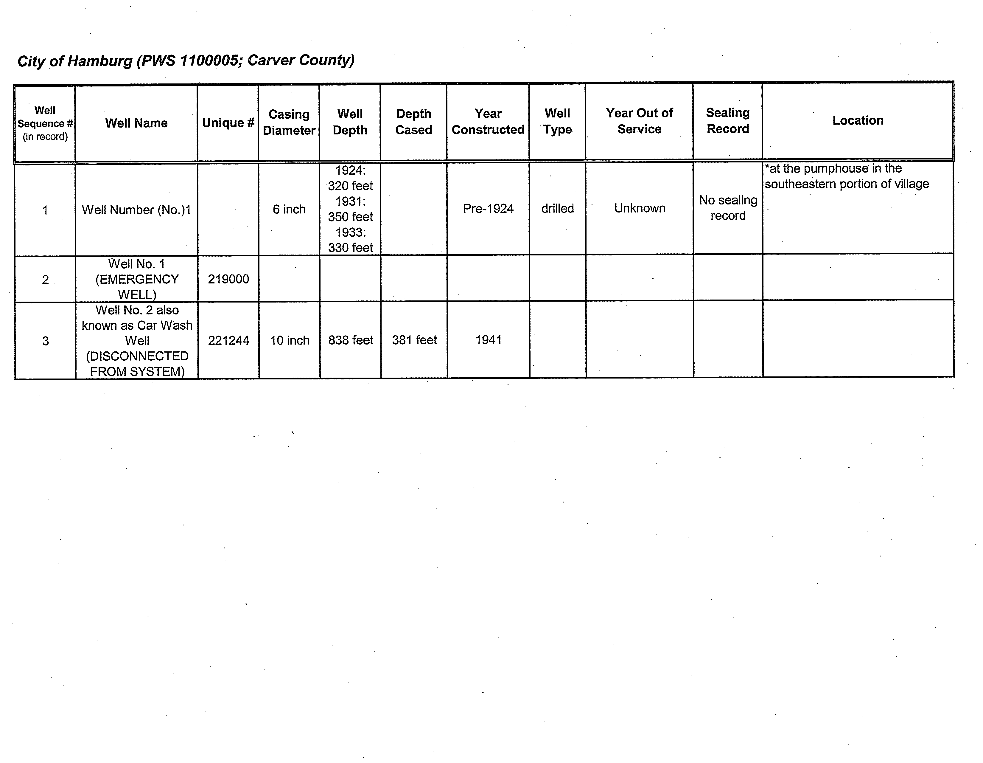
The Car Wash Well (221244) - The City of Hamburg staff believes the pump is still in place and that a cross connection exist with the City’s distribution system.

The City of Hamburg staff believe Well #1 (very first well) was located near the pumphouse by the water tower. City staff are uncertain as to the status of this well but believe they know its location.

Well #219000 is the emergency well currently used by the City of Hamburg.

Exhibit #9 - Scoping II Notice

September 12, 2007

Mr. Dennis Byerly
Water Superintendent - City of Hamburg
181 Broadway Avenue
Hamburg, Minnesota 55339

Dear Mr. Byerly:

Subject: Second Scoping Decision Notice
This letter provides notice of the results of a scoping meeting held with you, Jeremy Gruenhagen, city of Hamburg Clerk-Treasurer, Aaron Meyer, Minnesota Rural Water Association, and myself on August 20, 2007, at city hall regarding wellhead protection (WHP) planning. During the meeting we discussed the data elements that must be included and used to prepare the part of the WHP plan related to the management of potential contaminants in the approved drinking water supply management area. The enclosed Scoping 2 Decision Notice lists the data elements that were discussed at the meeting.
We also discussed the requirement to distribute copies of the first part of the WHP plan to local units of government and the requirement to hold an informational meeting for the public. Part I of the WHP plan was sent to local units of government on June 20, 2007, but the city still needs to meet the requirement for a public information meeting.
If a data element is marked on the enclosed notice as a data element that must be used and it does not exist, it is helpful if your plan notes this. Aaron Meyer will be working with you to develop a draft of the remainder of the WHP plan. I will be contacting you to review the progress of the development of Part II of your plan. If you have any questions regarding the enclosed notice, contact me by email at terry.bovee@health.state.mn.us or by phone at 507/389-6597.
Sincerely,
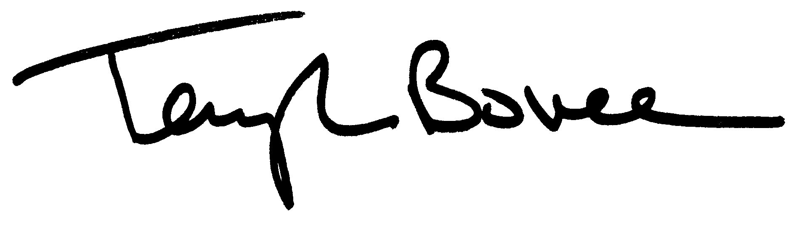
Terry L. Bovee, Principal Planner
Environmental Health Division
410 Jackson Street - Suite 500
Mankato, Minnesota 56001-3752

TLB:kmc
Enclosures
cc: Isaac Bradlich, Minnesota Department of Health
Chuck Regan, Minnesota Pollution Control Agency
Brian Williams, Minnesota Department of Agriculture
Melvin Sinn, Minnesota Department of Natural Resources
Eric Mohring, Board of Water and Soil Resources
Jeremy Gruenhagen, Clerk-Treasurer, City of Hamburg
Aaron Meyer, Minnesota Rural Water Association
SCOPING 2 DECISION NOTICE

- Remainder of the Wellhead Protection Plan

Name of Public Water Supply:  City of Hamburg PWSID 1100005 |  | Date:  September 12, 2007
Name of the Wellhead Protection Manager:

Mr. Dennis Byerly, Water Superintendent
Address:  181 Broadway Avenue | City:  Hamburg | Zip:  55339
Unique Well Numbers:  691883 (Well 2A), 691884 (Well 3), 219000 (Well 1 - Emergency)* |  | Phone:  952/467-3046
*Emergency wells only use the IWMZ Form for data collection.

Instructions for Completing the Scoping 2 Form

N | R | S | N = Not required.  If this box is checked, this data element is NOT necessary for your wellhead protection plan because it is not needed or it has been included in the first scoping decision notice. Please go to the next data element.
X
N | R | S | R = Required for the remainder of the plan.  If this box is checked, this data MUST be used for the "remainder of the plan."
 | X
N | R | S | S = Submit to MDH. If this box is checked, this data element MUST be included in your wellhead protection plan and submitted to MDH.  If there is NO check mark in the "S" box but there is an Ax@ in the “R” box, this data element MUST be included in your plan, but should NOT be submitted to MDH. This box will only be checked if MDH does not have access to this data element. This will help to reduce the cost by reducing the amount of paper and time to reproduce the data element.
 |  | X

Note: Any data elements required in the first scoping decision notice must also be used to complete the remainder of the wellhead protection plan.
DATA ELEMENTS ABOUT THE PHYSICAL ENVIRONMENT

PRECIPITATION
N | R | S | An existing map or list of local precipitation gauging stations.
X
Technical Assistance Comments:

N | R | S | An existing table showing the average monthly and annual precipitation in inches for the preceding five years.
X
Technical Assistance Comments:

GEOLOGY
N | R | S | An existing geologic map and a description of the geology, including aquifers, confining layers, recharge areas, discharge areas, sensitive areas as defined in Minnesota Statutes, section 103H.005, subdivision 13, and groundwater flow characteristics.
 | X
Technical Assistance Comments: The management of all the Drinking Water Supply Management Area(s) must reflect what is known about these data elements.
N | R | S | Existing records of the geologic materials penetrated by wells, borings, exploration test holes, or excavations, including those submitted to the department.
 | X
Technical Assistance Comments: The management of all the Drinking Water Supply Management Area(s) must reflect what is known about these data elements.
N | R | S | Existing borehole geophysical records from wells, borings, and exploration test holes.
 | X
Technical Assistance Comments: The management of all the Drinking Water Supply Management Area(s) must reflect what is known about these data elements.
N | R | S | Existing surface geophysical studies.
 | X |  | Existing surface geophysical studies.
Technical Assistance Comments: The management of all the Drinking Water Supply Management Area(s) must reflect what is known about these data elements.
SOILS
N | R | S | Existing maps of the soils and a description of soil infiltration characteristics.
X
Technical Assistance Comments:

N | R | S | A description or an existing map of known eroding lands that are causing sedimentation problems.
X
Technical Assistance Comments:

WATER RESOURCES
N | R | S | An existing map of the boundaries and flow directions of major watershed units and minor watershed units.
X
Technical Assistance Comments:

N | R | S | An existing map and a list of public waters as defined in Minnesota Statutes, section 103G.005, subdivision 15, and public drainage ditches.
X
Technical Assistance Comments:

N | R | S | The shoreland classifications of the public waters listed under subitem (2), pursuant to part 6120.3000 and Minnesota Statutes, sections 103F.201 to 103F.221.
X
Technical Assistance Comments:

N | R | S | An existing map of wetlands regulated under chapter 8420 and Minnesota Statutes, section 103G.221 to 103G.2373.
X
Technical Assistance Comments:
N | R | S | An existing map showing those areas delineated as floodplain by existing local ordinances.
X
Technical Assistance Comments:

DATA ELEMENTS ABOUT THE LAND USE

LAND USE
N | R | S | An existing map of parcel boundaries.
 | X | X | An existing map of parcel boundaries.
Technical Assistance Comments: The management of all the Drinking Water Supply Management Area(s) must reflect what is known about this data element.
N | R | S | An existing map of political boundaries.
 | X | X | An existing map of political boundaries.
Technical Assistance Comments: The management of all the Drinking Water Supply Management Area(s) must reflect what is known about this data element.
N | R | S | An existing map of public land surveys including township, range, and section.
 | X
Technical Assistance Comments: The management of all the Drinking Water Supply Management Area(s) must reflect what is known about this data element.

N | R | S | A map and an inventory of the current and historical agricultural, residential, commercial, industrial, recreational, and institutional land uses and potential contaminant sources.
 | X | X
Technical Assistance Comments: The inventory, mapping, and management of land uses and potential sources of contamination for all the Drinking Water Supply Management Area(s) must reflect what is known about these data elements, as follows:
Low Vulnerability - 1) All potential contaminant sources and facility designations as listed on the attachment, 2) a land use/land cover map and table, and 3) an inventory of the Inner Wellhead Management Zone (IWMZ).
As a starting point, MDH will provide:
- a list of specific potential sources of contamination from State data bases. At least 25 of each type of potential contaminant source must be inventoried, location verified, and mapped during plan development. The remaining sources, if any, must be inventoried, location verified and mapped during the first year of plan implementation and;
- a 1992 or 2001 land cover map and table from federal data bases. This data set must be used unless an alternative electronic data set that is more current and detailed is available.
Management strategies must be developed for the land uses and potential sources of contamination listed above.
N | R | S | An existing comprehensive land-use map.
 | X | X | An existing comprehensive land-use map.
Technical Assistance Comments: The management of all the Drinking Water Supply Management Area(s) must reflect what is known about this data element. Include any urban fringe planning areas.
N | R | S | Existing zoning map.
 | X | X | Existing zoning map.
Technical Assistance Comments: The management of all the Drinking Water Supply Management Area(s) must reflect what is known about this data element.
PUBLIC UTILITY SERVICES
N | R | S | An existing map of transportation routes or corridors.
X |  |  | An existing map of transportation routes or corridors.
Technical Assistance Comments:

N | R | S | An existing map of storm sewers, sanitary sewers, and public water supply systems.
X
Technical Assistance Comments:

N | R | S | An existing map of the gas and oil pipelines used by gas and oil suppliers.
X
Technical Assistance Comments:

N | R | S | An existing map or list of public drainage systems.
X |  |  | An existing map or list of public drainage systems.
Technical Assistance Comments:

N | R | S | An existing record of construction, maintenance, and use of the public water supply well(s) and other wells within the drinking water supply management area.
 | X
Technical Assistance Comments: The management of all the Drinking Water Supply Management Area(s) must reflect what is known about these data elements.

DATA ELEMENTS ABOUT WATER QUANTITY

SURFACE WATER QUANTITY
N | R | S | An existing description of high, mean, and low flows on streams.
X
Technical Assistance Comments:

N | R | S | An existing list of lakes where the state has established ordinary high water marks.
X
Technical Assistance Comments:

N | R | S | An existing list of permitted withdrawals from lakes and streams, including source, use, and amounts withdrawn.
X
Technical Assistance Comments:

N | R | S | An existing list of lakes and streams for which state protected levels or flows have been established.
X
Technical Assistance Comments:

N | R | S | An existing description of known water-use conflicts, including those caused by groundwater pumping.
X
Technical Assistance Comments:

GROUNDWATER QUANTITY
N | R | S | An existing list of wells covered by state appropriation permits, including amounts of water appropriated, type of use, and aquifer source.
 | X
Technical Assistance Comments: The management of all the Drinking Water Supply Management Area(s) must reflect what is known about these data elements.
N | R | S | An existing description of known well interference problems and water use conflicts.
 | X
Technical Assistance Comments: The management of all the Drinking Water Supply Management Area(s) must reflect what is known about these data elements.
N | R | S | An existing list of state environmental bore holes, including unique well number, aquifer measured, years of record, and average monthly levels.
 | X
Technical Assistance Comments: The management of all the Drinking Water Supply Management Area(s) must reflect what is known about this data element.
DATA ELEMENTS ABOUT WATER QUALITY

SURFACE WATER QUALITY
N | R | S | An existing map or list of the state water quality management classification for each stream and lake.
X
Technical Assistance Comments:

N | R | S | An existing summary of lake and stream water quality monitoring data, including:  1. bacteriological contamination indicators; 4. sedimentation;  2. inorganic chemicals; 5. dissolved oxygen; and  3. organic chemicals; 6. excessive growth or deficiency of aquatic plants.
X
Technical Assistance Comments:

GROUNDWATER QUALITY
N | R | S | An existing summary of water quality data, including: 1. bacteriological contamination indicators; 2. inorganic chemicals; and 3. organic chemicals.
 | X
Technical Assistance Comments: The management of all the Drinking Water Supply Management Area(s) must reflect what is known about these data elements.
N | R | S | An existing list of water chemistry and isotopic data from wells, springs, or other groundwater sampling points.
 | X
Technical Assistance Comments: The management of all the Drinking Water Supply Management Area(s) must reflect what is known about these data elements.
N | R | S | An existing report of groundwater tracer studies.
 | X |  | An existing report of groundwater tracer studies.
Technical Assistance Comments: The management of all the Drinking Water Supply Management Area(s) must reflect what is known about this data element.
N | R | S | An existing site study and well water analysis of known areas of groundwater contamination.
 | X
Technical Assistance Comments: The management of all the Drinking Water Supply Management Area(s) must reflect what is known about these data elements.
N | R | S | An existing property audit identifying contamination.
 | X |  | An existing property audit identifying contamination.
Technical Assistance Comments: The management of all the Drinking Water Supply Management Area(s) must reflect what is known about this data element.
N | R | S | An existing report to the Minnesota Department of Agriculture and the Minnesota Pollution Control Agency of contaminant spills and releases.
 | X
Technical Assistance Comments: The management of all the Drinking Water Supply Management Area(s) must reflect what is known about this data element.

Exhibit 10 – Hamburg Development Plan

